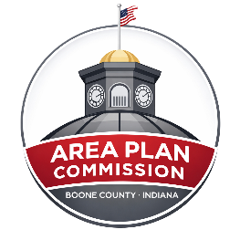 | Meeting Agenda  Boone County Area Plan Commission (APC)  Lamar Meeting Room - Boone County Government Building  November 4, 2026, at 7:00pm

ZOOM LINK- https://zoom.us/j/4874385613
Please mute your audio while on the call.

Opening:
- Call Public Meeting to Order - Meeting Begins at 7:00pm
- Pledge of Allegiance
- Approval of September 7, 2026 Minutes
- Agenda Consideration

Continued Public Hearings:

Other Old Business:

- New Business Public Hearings:
- 26MA-25-261 Lyon; Petition for a Plat Amendment to split another parcel from the existing Lot 2 to create a 5.0 acre parcel as lot 2A (lot 3).
  - Application File
  - Staff Report

- 26SC-7M-263 Land/Swift; Petition for a Special Exception and Minor Residential Subdivision to create 4 5-acre parcels.
  - Application File
  - Staff Report

- 26CE-CP-275 APC; Petition to update the Comprehensive Plan for the Unincorporated area of Boone County and Town of Advance.
  - Public Hearing Draft

- 26CE-CP-275 APC; Petition to update the Thoroughfare Plan for Boone County.
  - Public Hearing Draft

- Other New Business / New Business from the Floor
- Local Road Safety Plan - HWC
- Unified Development Ordinance – Vote Required to start process to amend zoning ordinance

- Director Report

- Announcements

- Public Comment on Items not on the Agenda

- Adjournment

Agenda subject to change.
*Public Testimony: Any written comments or objections to the proposals that are filed with the Area Plan Commission office before the hearing will be considered. Any oral comments concerning the proposals will be heard by the BZA at the hearing. In addition, the hearing may be continued from time to time by the BZA, as it may find necessary. Please check with the APC office for any cancellations.
The Boone County Area Plan Commission acknowledges its responsibility to comply with the American Disabilities Act of 1990. In order to assist individuals with disabilities who require special services (i.e. sign interpretative services, alternate audio/visual devices, and amanuenses) for participation in or access to county sponsored public programs, services and or meetings, the county request that individuals make request for these services forty-eight (48) hours ahead of the scheduled program, services and/or meeting. To make arrangements, contact Ashley Elliott, Administrative Assistant, at (765) 482-3821.

