Minutes of the June 24, 2026, Meeting

The Boone County Area Plan Commission met in a regular session at 7:00 PM on Wednesday, June 24, 2026, in the Conference Room at the Boone County Justice Center located at 1905 Indianapolis Ave., Lebanon, IN 46052 with the following personnel in attendance:

Members Attending: John Merson, Jay Schaumerg, Danielle Morrison and Sheldon Hutchens

Members Absent: Brent Henschen

Staff Attending: Nicole M. Schell (Executive Director), Ashley Elliott (Administrative Assistant) and Bob Cutter (Attorney for the Boone County BZA and APC)

YouTube Link to Meeting

DETERMINATION OF QUORUM AND PLEDGE OF ALLEGIANCE

John Merson opened the meeting at 7:00pm by leading the Pledge of Allegiance. Introductions followed.

Determination of Quorum: 4 of 5 members present.

Approval of the Agenda:
None at this time.

APPROVAL OF MINUTES

Danielle Morrison made a motion to approve the minutes from May 27, 2026, meeting.
Sheldon Hutchens seconded the motion. Motion carried 4-0.

CONTINUED PUBLIC HEARINGS

None at this time.

IN THE MATTER OF OLD BUSINESS

None at this time.

IN THE MATTER OF NEW BUSINESS

1. 26CE-14-098 Morrolina Construction, LLC/Laycock; Variance from Development Standards from the 40-ft AG Bufferyard on the east side of the property to build an addition on the home.

Executive Director Nicole M. Schell read the staff report.

Paul Morrison with Morrolina Construction came forward on behalf of this petition.

Board Comments/Questions for Petitioner:
President John Merson asked if their setbacks are the same as the existing house?
Petitioner Paul Morrison responded correct.

Public Comments:
None.

Board Comments:
None.

Motion:

Jay Schaumberg made a motion to approve 26CE-14-098 with the conditions stated in the staff report. Danielle Morrison seconded the motion. Motion carried 4-0.

2. 26JA-14-099 Jeppe and Danielle Nelson; Variance from Development Standards from accessory structure height and size larger than the primary. An additional variance is needed for cumulative Accessory area in order to build a 3456 sq ft accessory structure.

Executive Director Nicole M. Schell read the staff report.

Jeppe Nelson came forward on behalf of this petition.

Board Comments/Questions for Petitioner:
None.

Public Comments:
None.

Board Comments:
None.

Motion:

Sheldon Hutchens made a motion to approve 26JA-14-099 with the conditions stated in the staff report. Jay Schaumberg seconded the motion. Motion carried 4-0.

3. 26JE-14-108 Christman Brothers Buildings/Kyle Schwarzkopf; Variance from Development Standards from accessory structure height and size larger than the primary structure. Additional variances are required for accessory structure sq ft larger than 3,000 sq ft and cumulative area larger than 4,000 sq ft. to build a 3,888 sq ft accessory structure.

Executive Director Nicole M. Schell read the staff report.

Jay Christman with Christman Builders came forward on behalf of this petition.

Board Comments/Questions for Petitioner:
None.

Public Comments:
John Bevington came forward and stated the only problem he has is that he also has a petition to rezone from agriculture to residential, which he is against and doesn’t want houses over there.
Executive Director Nicole M. Schell responded that the office has not received any petitions to rezone the property.
Attorney Bob Clutter stated that his petition is for a Variance request and not a rezone request.
Petitioner Kyle Schwarzkopf then came forward to address the questions and concerns of Mr. Bevington.

Board Comments:
None.

Motion:

Danielle Morrison made a motion to approve 26JE-14-108 with the conditions stated in the staff report. Sheldon Hutchens seconded the motion. Motion carried 4-0.

4. 26HA-14-130 Hoover Homes/Kipp Hosfield; Variance from development standards for:
1) An accessory structure larger in Sq. Ft. than the Primary
2) An accessory structure taller than the Primary

Executive Director Nicole M. Schell read the staff report.

Ryan Hoover came forward on behalf of this petition.

Board Comments/Questions for Petitioner:
None.

Public Comments:
None.

Board Comments:
None.

Motion:

Sheldon Hutchens made a motion to approve 26HA-14-130 with the conditions stated in the staff report. Danielle Morrison seconded the motion. Motion carried 4-0.

5. 26JE-7M-055 Paul and Phyllis Nicley; Special Exception with Minor Plat to convert 2 existing parcels into 4 parcels with a shared access driveway. Proposed lot 4 requires a variance from the 3:1 depth to width ratio

Executive Director Nicole M. Schell read the staff report.

Surveyor Jim Swift came forward on behalf of this petition.

Public Comments:
Neighbor Opposition: Residents (the Gosnell’s and Shaw’s) expressed significant concerns regarding:
  - Safety & Traffic: Increased vehicle traffic and construction near their homes/children.
  - Environmental Impact: Potential for dust (affecting a resident with lung cancer concerns), noise, and changes to the rural character.
  - Drainage: Potential for road washout, flooding, and impact on the local water table/septic systems.
  - Privacy: Loss of privacy due to the proximity of the proposed shared driveway to existing homes.
Petitioner's Defense: The representative argued that the lot geometry was established prior to current subdivision codes and noted that a similar project was approved nearby last year. The owner expressed willingness to mitigate neighbor concerns through physical buffers.
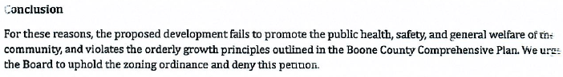
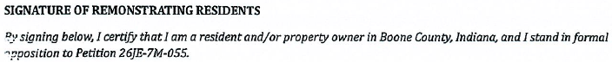
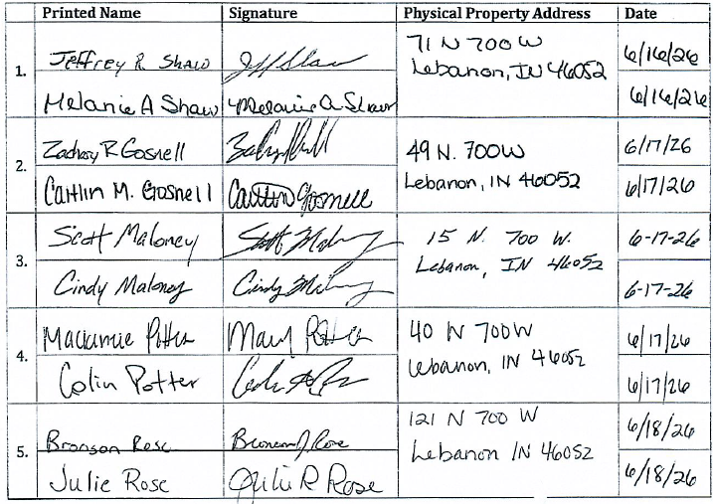

Board Comments:
The board discussed the neighbor’s opposition and ways to mitigate those concerns. Items discussed included the addition of a paved driveway, fencing, and landscaping.

Motion:

John Merson made a motion to approve 26JE-7M-055 with the following requirements:
- Approval of the special exception for minor residential subdivision and variances for road frontage and 3:1 lot depth-to-width ratio.
- A minimum 20-foot wide paved driveway extending from 700 West to the easternmost drives on lots two and four.
- Installation of a fence on each side of the driveway between the Gosnell and Shaw properties.
- A minimum three-foot berm with evergreens on the west side of plots one and three.
- Adherence to all previous staff-recommended conditions (home orientation, subdivision limits, setback increases, and shared maintenance/drainage agreements).
Danielle Morrison seconded the motion. Motion carried 4-0.

6. 26MA-7M-075 Brian Kincaid; Special Exception with Minor Plat to split the existing parcel into three lots

Executive Director Nicole M. Schell read the staff report.

Brian Kincaid came forward on behalf of this petition.

Board Comments/Questions for Petitioner:
None.

Public Comments:
None.

Board Comments:
None.

Motion:

Sheldon Hutchens made a motion to approve 26MA-7M-075 with the conditions stated in the staff report. Jay Schaumberg seconded the motion. Motion carried 4-0.

7. 26CL-14-135 Derek Gray and Rebecca Bull; Petition for a variance from development standards on: Cumulative sq ft of accessory structures from 4,000 to 17,000 sq ft, Size of signal accessory structure from 3,000 to 9,600 sq ft, and Area of accessory structure larger than the primary.

Executive Director Nicole M. Schell read the staff report.

Derek Gray came forward on behalf of this petition.

Board Comments/Questions for Petitioner:
None.

Public Comments:
None.

Board Comments:
None.

Motion:

Danille Morrison made a motion to approve 26CL-14-135 with the conditions stated in the staff report. Sheldon Hutchens seconded the motion. Motion carried 4-0.

VIOLATION REPORT

None at this time.

ADMINISTRATIVE MATTERS

- Other New Business / New Business from Floor:
None.

- Announcements:
None.

- Public Comment on Items not on the Agenda:
None.

______________________________________________________________________________
ADJOURNMENT

With no further business, Jay Schaumberg made a motion to adjourn at 8:43pm.
Danielle Morrison seconded the motion. Motion carried 4-0.

