Minutes of the June 3, 2026, Meeting

The Boone County Area Plan Commission met in regular session at 7:00 PM on Wednesday, June 3, 2026, in the Connie Lamar Meeting Room located on the main floor of the Boone County Annex Building at 116 W. Washington Street, Room 105, Lebanon, IN 46052 with the following personnel in attendance:

Members Attending: Matt Johnson, John Merson, Tad Braner, Carol Cunningham, Dustin Plunkett and Commissioner Donnie Lawson

Members Absent: Jay Schaumberg

Staff Attending: Nicole M. Schell (Executive Director), Ashley Elliott (Administrative Assistant) and Bob Clutter (Attorney for the Boone County BZA and APC)

YouTube Link to Meeting

DETERMINATION OF QUORUM AND PLEDGE OF ALLEGIANCE

John Merson opened the meeting at 7:00pm by leading the Pledge of Allegiance. Introductions followed.

Determination of Quorum: 6 of 7 members present.

Approval of the Agenda:
None at this time.

APPROVAL OF MINUTES FOR:

Approval of Minutes for May 6, 2026:
Carol Cunningham made a motion to approve the minutes from May 6, 2026.
Matt Johnson seconded the motion. Motion carried 6-0.

RFP OPENING

1. Opening of RFP Submittals for the Permitting Software

Executive Director Nicole M. Schell presented the below 22 proposed vendors below to the board:
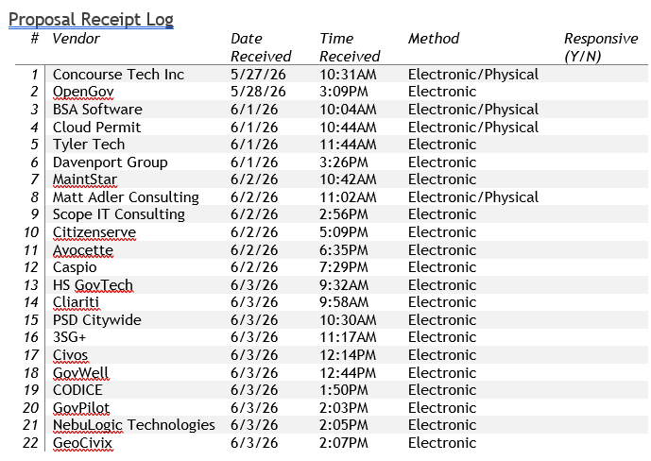

Motion:

Commissioner Donnie Lawson made a motion to take under advisement.
Dustin Plunkett seconded the motion. Motion carried 6-0.

___________________________________________________________________

IN THE MATTER OF CONTINUED BUSINESS

1. 25WA-16-130 IMI/Irving Materials; Requesting a Zone Map Change from Agricultural (AG) to Light Industrial (I1) for the purpose of Constructing a ready-mix Concrete Plant

** Petitioner Requested Continuance to a Future Meeting

2. 26MA-16-058 Badger/Hollingworth; Petitioner is Requesting a Zoning Map Change from Local Business (LB) to General Business (GB) to Accommodate a New Gas Station and Convenience Store

Executive Director Nicole M. Schell read the staff report.
Chris Badger with Badger Engineering came forward on behalf of this petition.

Board Comments/Questions:
Commissioner Donnie Lawson asked Mr. Badger about a house currently there and whether the whole area will be torn out of there?
Mr. Badger responded yes and mentioned that there are other people planning on putting in a gas station and are willing to work with them.

Public/Board Comments:
Phillip Going with Acura Land Surveying came forward on behalf of his client who purchased the Northwest corner intersection for the intent to put a gas station/convenient store on that corner, because the site had supposedly been a gas station/convenient store in the past.
Mr. Going stated he was surprised when learning about this project and is appearing here to be against him. Mr. Going said on behalf of his client that the corner may not support 2 gas stations at this time. Mr. Going stated he wanted the board to consider the fact the site on the Northwest corner has historically been a gas station and his client intends to build on the site and wants the board to consider that before approving this petition.
Member John Merson asked Executive Director Nicole M. Schell about the 4 corners of land on that intersection that are currently zoned Local Business (LB).
Executive Director Nicole M. Schell replied that it’s only on that Westside of US 421.
Member John Merson then asked, “Is it North and South of CR 300 and if so, how much?
Executive Director Nicole M. Schell responded yes, and it is 4 parcels in the North and then a gap of General Business (GB) and the fourth parcel is Local Business (LB) and the 3 other parcels that are in this that have 2 deeded parcels and 1 separate parcel and that is on the Southside of CR 300 that is zoned Business. Outside of that everything else is zoned Agricultural (AG).
Dean Barkley came forward, who currently lives at the 3010 property that is North of Mr. Badger’s project and asked the Executive Director for clarification on whether the application says State Road 421 or US 421, because that would be the first mistake.
Executive Director Nicole M. Schell responded that it is US 421.
Dean Barkley then went on to state that if we look at the tax records on the property at 2996 N. US 421 it’s zoned Residential and being taxed as Residential and some years ago I was looking into putting an addition onto the shop onto the 3010 property, but its was drawn then that the Southside of 300 was zoned Residential or Agriculture and didn’t show the 3 properties you just mentioned and is that something that has just changed and if it hasn’t changed why has 2996 been charged Residential taxes, but 3010 is on a Commercial basis and does that make a difference if we’re leaping from a Residential to a General Business (GB) or are we changing it to Local Business (LB), because it used to be a gas station and should stay a gas station.
Mr. Badger then came forward and stated he finds it funny they didn’t file, but they’re stating they will file and their property is very small and arguing a proposed thing versus something he has already filed and hasn’t seen anything go through the State on that.
Member John Merson asked Mr. Badger if he had been in contact with the landowners he would be crossing with your 600 feet of drainage?
Mr. Badger responded that the distance of the right-of-way we are going to put it in and create a new roadside ditch.
Member John Merson asked Mr. Badger if he knew the distance from the project to the closest subdivision or commercial.
Mr. Badger responded he wasn’t sure, but he could get that for them.
Member Tad Braner stated that some people are saying that hadn’t been notified because he noticed there was no one in the crowd speaking out against this.
Mr. Badger responded yes and that it was notified in the newspaper as well.

Board Comments:
Member Carol Cunningham stated she does have concerns over the drainage and understands their working with the Highway Department to put in drainage on the side of the road and that in her past years that has been a not allowed. She is also concerned about switching to LB (Local Business) to GB (General Business) because it’s kind of a residential/agricultural use and what types of things that could be put in GB (General Business).
Member Matt Johnson asked if they had a plan B if the Highway Department won’t allow public or private usage.
Mr. Badger responded that there are other methods.
Member John Merson asked if there would be unlimited access to that drain.
Member Carol Cunningham responded yes if it’s a public drain everybody can access it.
Commissioner Donnie Lawson mentioned that whether we like it or not the County is growing and understands why they want to have a convenience store there and another thing he sees along there is heavy traffic, but people are looking for convenience and some things probably need to be looked at a little closer and see’s the good and the bad about it, but at some point in time we need to move forward.
Member Dustin Plunkett stated leading up prior to the meeting he had quite a few phone calls from folks in that area and weren’t overly excited about the project and on top of Carol’s point as far as just the zone change and that is a concern in the aspect of that if they get the zoning change and is that what would be going up or if they changed their minds and do something else.
Attorney Bob Clutter responded that they could make a written commitment that it will stay a gas station convenient store.
Member Dustin Plunkett then responded that the amount of phone calls he had on it was surprised that there is not 8-10 people in here and the traffic there is pretty rough at this point and he understands new lanes and he thinks in a few years those lanes are coming anyways, but he would feel better down the road figuring that out as far as he doesn’t want the whole community around the gas station.
Member Tad Braner stated he doesn’t really have any comments, but he’s opposed to it.
Member John Merson stated his view on this is that eventually growth may come up to that intersection but sounds like it’s about 5 miles away right now and has concerns approving this project but thinks in the future this project would make sense.

Motion:

Tad Braner made a motion to send 26MA-16-058 with an unfavorable recommendation to the Boone County Commissioners. Dustin Plunkett seconded the motion. Motion carried 5-0 with 1 obtained (Commissioner Donnie Lawson).

IN THE MATTER OF OLD BUSINESS

1. 26ZO-16-128 Moratorium on Data Centers; Boone County Area Plan Commission is Recommending a 1-year Moratorium to the County Board of Commissioners

Executive Director Nicole M. Schell spoke and gave information regarding a 1-year Moratorium.

Public Comments:
Several people from the public came forward in support of the 1-year Moratorium.

Board Comments:
Executive Director wanted the board to know that Victoria Wessler sent in a letter in support of the 1-year Moratorium.

Motion:

Dustin Plunkett made a motion to send 26ZO-16-128 with a favorable recommendation to the Boone County Commissioners. Tad Braner seconded the motion. Motion carried 6-0.

IN THE MATTER OF NEW BUSINESS

1. 26CE-16-090 Eli Lilly Company; Petition for Zone Map Change to Convert 4 Parcels:
001-05610-00 & 001-05670-03 & 001-05670-01 & 001-05670-04 from General Agriculture (AG) to Light Industrial (I1)

Executive Director Nicole M. Schell read the staff report.
Kyle Chambers with TAFT Law came forward on behalf of this petition.

Public Comments:
None.

Board/Petitioner Questions:
Member John Merson asked why isn’t it annexed?
Kyle Chambers responded that still within County we wanted to make sure the stop work orders were taken care of and to do right under the current zoning, but as for the annexation for the future we have no set plans for that.
Dustin Plunkett stated his question was more for Surveyor Carol Cunningham regarding the TAC comments and if they leveled it would require a drainage plan.
Member Carol Cunningham responded yes, it would. She also mentioned that she is waiting on a plan from Kimberly & Horn and has not received it yet.

Motion:
Commissioner Donnie Lawson made a motion to send 26CE-16-090 with a favorable recommendation to the Boone County Commissioners. Tad Braner seconded the motion. Motion carried 6-0.
______________________________________________________________________________

VIOLATION REPORT

None at this time.

ADMINISTRATIVE MATTERS

- Other New Business / New Business from the Floor:
None.

- Announcements:
Executive Director Nicole M. Schell gave the board an update on the Comprehensive Plan and let the board know that the next APC meeting on July 1, 2026, at 7pm, will be held at the Justice Center in the Main Lobby.

3. Public Comment on Items not on the Agenda:
None.
______________________________________________________________________________

ADJOURNMENT

With no further business, Dustin Plunkett made a motion to adjourn at 8:04pm.
Tad Braner seconded the motion. Motion carried 6-0.

