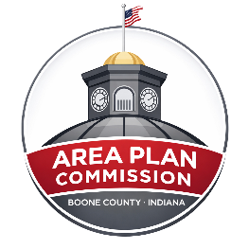 | Meeting Agenda  Boone County Area Plan Commission (APC)  Boone County Justice Center – 1905 Indianapolis Ave  Main Entrance - Conference Room off the Lobby  July 1, 2026, at 7:00pm

ZOOM LINK- https://zoom.us/j/4874385613
Please Mute your Audio while on the Call.

A. Opening:

- Call Public Meeting to Order - Meeting Begins at 7:00pm
- Pledge of Allegiance
- Approval of June 3, 2026, Minutes
- Agenda Consideration

B. Continued Public Hearings:

C. Other Old Business:

None at this time.

D. New Business Public Hearings:

- 26JE-7M-055 Paul and Phyllis Nicley; Petition for a Special Exception with Minor Plat to Convert 2 Existing Parcels into 4 Parcels with a Shared Access Driveway. Proposed Lot 4 Requires a Variance from the 3:1 Depth to Width Ratio
- Application File
- Staff Report

- 26MA-7M-075 Brian Kincaid; Petition for a Special Exception with Minor Plat to Split the Existing Parcel into 3 Lots
- Application File
- Staff Report

- 26ZO-16-151 Area Plan Commission; Amendment to APC Membership
a. Application File

E. Other New Business / New Business from the Floor
- RFP Permitting Platform Update

F. Announcement

- The 2025 Boone County Comprehensive Plan is now available for public review at www.planbooneco.com.

G. Public Comment on Items not on the Agenda

H. Adjournment

Agenda subject to change.
*Public Testimony: Any written comments or objections to the proposals that are filed with the Area Plan Commission office before the hearing will be considered. Any oral comments concerning the proposals will be heard by the BZA at the hearing. In addition, the hearing may be continued from time to time by the BZA, as it may be found necessary. Please check with the APC office for any cancellations.
The Boone County Area Plan Commission acknowledges its responsibility to comply with the American Disabilities Act of 1990. In order to assist individuals with disabilities who require special services (i.e. sign interpretative services, alternate audio/visual devices, and amanuenses) for participation in or access to county sponsored public programs, services and or meetings, the county request that individuals make request for these services forty-eight (48) hours ahead of the scheduled program, services and/or meeting. To make arrangements, contact Ashley Elliott, Administrative Assistant, at (765) 482-3821.

