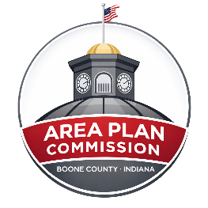 | Meeting Agenda  Boone County Board of Zoning Appeals (BZA)  Lamar Meeting Room - Boone County Government Building  March 25, 2026, at 7:00pm

ZOOM LINK- https://zoom.us/j/4874385613
Please mute your audio while on the call.

A. Opening:

1. Call Public Meeting to Order - Meeting Begins at 7:00pm
2. Pledge of Allegiance
3. Approval of February 25, 2026, Minutes
4. Agenda Consideration

B. Continued Public Hearings:

1. 26WA-7-005 Matthew Roseman; Special Exception to Construct an 800 sq. ft. Accessory Dwelling unit within
an Existing Accessory Structure
- Application File
- Staff Report

C. Other Old Business:

None at this time.

D. New Business Public Hearings:

- 26CE-14-020 Rex Princell; Variance from Development Standards to Allow an Accessory Structure Larger than the Primary Structure
- Application File
- Staff Report

- 26CE-14-023 Michalak/ Indy Grills; Variance from Development Standards from the 40-foot Agricultural (AG) Buffer Yard Requirement
- Application File
- Staff Report

- 26CL-14-031 Caleb and Whitney Michalke; Variance from Development Standards for an Accessory Structure Larger than the Primary in Height and Area
a. Application File
b. Staff Report

E. Other New Business / New Business from the Floor

F. Announcements

G. Public Comment on Items not on the Agenda

H. Adjournment

Agenda subject to change.
*Public Testimony: Any written comments or objections to the proposals that are filed with the Area Plan Commission office before the hearing will be considered. Any oral comments concerning the proposals will be heard by the BZA at the hearing. In addition, the hearing may be continued from time to time by the BZA, as it may find necessary. Please check with the APC office for any cancellations.
The Boone County Area Plan Commission acknowledges its responsibility to comply with the American Disabilities Act of 1990. In order to assist individuals with disabilities who require special services (i.e. sign interpretative services, alternate audio/visual devices, and amanuenses) for participation in or access to county sponsored public programs, services and or meetings, the county request that individuals make request for these services forty-eight (48) hours ahead of the scheduled program, services and/or meeting. To make arrangements, contact Ashley Elliott, Administrative Assistant, at (765) 482-3821.

