BOONE COUNTY COMMISSIONERS BOONE COUNTY, INDIANA

Request for Quotations (RFQ)
SECTION 27 41 16 – Integrated audio-video system for Council Chambers for the Connie Lamar Meeting/Conference Room

February 2, 2026

BOONE COUNTY COMMISSIONERS
Table of Contents

SECTION 1 BACKGROUND AND SCOPE OF SERVICES
  - BACKGROUND ..................................................................................... 3
  - EXISTING ENVIRONMENT................................................................... 3
  - PROJECT LOCATIONS .......................................................................... 3
SECTION 2 GENERAL INFORMATION FOR THIS RFQ
  - PURPOSE OF THIS RFQ.......................................................................... 4
  - ISSUER .................................................................................................... 4
  - NON-DISCLOSURE................................................................................. 4
  - INCURRING COSTS................................................................................ 4
  - PROCUREMENT SCHEDULE ............................................................... 5
    - Request for Quote Mailed ....................................................... 5
    - Questions Regarding RFQ ........................................................... 5
    - Responses to Written Questions .................................................. 5
    - Deadline for Response ................................................................ 5
    - Award Date ................................................................................ 5
  - ACCEPTANCE OF QUOTE CONTENT........................................... 5
  - PRIME CONTRACTOR RESPONSIBILITIES........................................ 5
  - VENDOR SELECTION CRITERIA ........................................................ 6
SECTION 3 VENDOR REQUIREMENTS UNDER THIS RFQ
  - INTRODUCTION..................................................................................... 7
  - BASIC SERVICES TO BE PROVIDED UNDER THIS RFQ ................... 7
    - Ability to Deliver Product.......................................................... 7
    - Vendor Profile............................................................................ 7
    - Response……............................................................................. 7
SECTION 4 VENDOR RESPONSE
  - GENERAL INSTRUCTIONS.................................................................... 8
  - VENDOR RESPONSE.............................................................................. 8
  - ADDITIONAL REQUIREMENTS........................................................... 8
  - REFERENCES……….............................................................................. 9
ATTACHMENTS
- SECTION 27 41 16 – Integrated audio-video system for Council Chambers
- AV-101 – Functional Diagram

Page 2

SECTION 1 BACKGROUND AND SCOPE OF SERVICES

  - Background- The Board of Commissioners of Boone County is the governing body of Boone County Indiana. Their offices are located at 127 W. Main Street, Suite 400, Lebanon, Indiana, 46052. The county has recently created an AV committee to look at options to rebuild and enhance the audio-visual environment in the Connie Lamar meeting / conference room. The RFQ that follows represents the desired functionality of the room following award of bid.

  - Existing Environment – Certain services / equipment and devices described above are currently being provided by a 10-year-old hardware/software/technology solution inside the Connie Lamar meeting/conference room. The current platform does not meet the needs of the county personnel or the public while participating in or attending meetings online. As a part of that effort this Request for Quote (RFQ) is being issued to satisfy the purchasing of requested services as described elsewhere in this document.

  - Project Location - Boone County Annex
116 West Washington Street Lebanon, IN 46052

SECTION 2 GENERAL INFORMATION FOR THIS RFQ

  - Purpose of This RFQ - The purpose of this RFQ is to obtain Bids for
“SECTION 27 41 16 – Integrated audio-video system for Council Chambers”
for the County Commissioners to enhance and update the audio-visual environment for county personnel and the general public during meetings, training sessions, etc.
  - Issuer - This RFQ is being issued by the following people in care of the county: Boone County Commissioners Telephone: (765) 483-4492
127 W. Main Street, Suite 400
Lebanon, IN 46052

  - Non-Disclosure - Information pertaining to Boone County obtained by the Vendor as a result of its participation in relation to this RFQ is confidential and shall not be disclosed or used by the Vendor except as authorized herein by the Boone County Commissioners. The content of your response will be held in confidence and will not be divulged to any other Vendor.

The Commissioners reserve the right to share information with any consultant of their choosing, the RFQ, and any resultant response in order to secure an expert opinion. The consultant shall be required to sign a non-disclosure agreement guaranteeing that all information received pertaining to this RFQ or subsequent contract shall be held in confidence.

  - Incurring Costs - The Boone County Commissioners are not liable for any cost incurred by any Vendor in connection with said Vendor’s response to this RFQ.

The Boone County Commissioners reserve the right to accept or reject any or all response(s) to this RFQ and shall be under no obligation to explain any such rejection. It is to be expressly understood by each respondent that no liability will be incurred by the Boone County Commissioners by reason of the rejection of or failure to accept the respondent’s quotation.

The Boone County Commissioners reserve the right to cancel the proposed RFQ at any time prior to the execution of a written contract without any liability to the Boone County Commissioners if, in its sole determination, its best interest would be served by doing so.

Once the full process has been exercised and funds are available to support a contract the project will move forward. In the event that the current funds do not support the project, the commissioners reserve the right to postpone or cancel this project.

  - Procurement Schedule - Vendors must adhere to the following schedule of events in the procurement process. The Commissioners reserve the right to change this schedule at any future date.
    - Request for Quote Available: February 2, 2026, through February 27, 2026

1. 2.5.2 Questions regarding this RFQ are to be submitted via email to itdepartment@co.boone.in.us no later than: 4:00 p.m. February 13, 2026. Phone calls and/or in person visits are not permitted.

Responses to any written questions to all Vendors by:
4:00 p.m. February 20, 2026.

    - Deadline for Receipt of RFQ Responses: Responses must be received by the Boone County Commissioners before 3:00 p.m. Friday February 27, 2026. Responses received after the due date will be returned to the Vendor unopened.

    - Bid Opening and Review: Proposals will be opened during a public meeting on Monday, March 9, 2026, and subsequently provided to the Boone County IT Department for review.

    - Award Date: March 23, 2026

  - Acceptance of Quotation Content - The content of this RFQ and the quotation submitted by the Vendor will be included as part of the contractual obligations if a contract ensues. Failure of the successful Vendor to accept the obligations stated within this RFQ, unless otherwise agreed to in writing by both the Vendor and the Commissioners may result in cancellation of the award of the contract.

  - Prime Contractor Responsibilities - The primary Vendor will be required to assume responsibility for all contractual activities offered in this quotation whether or not that Vendor actually performs them. Further, the Commissioners will consider the primary Vendor to be the sole point of contact with regard to contractual matters, including payment of any and all charges resulting from anticipated contract. If any part of the work is to be subcontracted, responses to this RFQ must indicate the following information:

< List of all subcontractors
< Subcontractor name and address
< Complete description of work to be subcontracted
< Descriptive information concerning the subcontractor’s organization.

The Commissioners reserve the right to approve subcontractors for any portion of services required under this RFQ and to require the primary Vendor to replace subcontractors found to be unacceptable. The primary Vendor is responsible for adherence by the subcontractor to all provisions of the contract. In addition, the activities performed by all subcontractors must be integrated with operations/location of the primary Vendor, such that the Commissioners perceive a single entity from an operational standpoint.

  - Vendor Selection Criteria - Responses to this RFQ will be evaluated based upon the following factors:

< Cost
< Verified ability to perform the work
< References

SECTION 3 VENDOR REQUIREMENTS UNDER THIS RFQ

  - Introduction - The information contained in this section include the minimum specifications to be rendered under this RFQ. Once a contract is awarded, any deviation from these minimum requirements must be stated in writing and must be approved in writing by the Boone County Commissioners.

Basic Services to be Provided Under this RFQ:

The successful Vendor will be required to provide but not limited to the following services:

    - Vendor Profile - Please provide information as listed in section 5.1.

    - Ability to secure and deliver a solution that meets the requirements listed in section 27 41 16 & AV-101. The Commissioners will only accept Quotes that meet these criteria. Any quotation that does not indicate and explain how it will meet the requirements will not be considered or accepted.

    - Response – The Response must be clearly marked and received before 3:00 p.m. Friday February 27, 2026.

The Boone County Commissioners 127 W. Main Street
Suite 400
Lebanon, IN 46052
“Integrated Audio-Video System for Council Chambers”

SECTION 4 VENDOR RESPONSE

General Instructions:

The Vendor will be required to provide four (4) copies of the response by 3:00 p.m. on February 27th, 2026, to the following:

The Boone County Commissioners 127 W. Main Street
Suite 400
Lebanon, IN 46052
“Integrated Audio-Video System for Council Chambers”

The Vendor will provide information as a part of their response on the following items:

- A list of all personnel to be assigned to this project and their responsibilities relating to the project.
- Any other conditions the Vendor wishes to provide as a part of their response.

Vendor Response

Company Name Company Address Primary Contact Telephone Number

Base Bid Amount (in numbers) $

Base Bid Amount (in words)

Additional Requirements

A 5% Bid Bond Must accompany this proposal.

A 100% Performance & Payment Bond will be required of the winning bidder. The Completed Reference Page must accompany the bid.

  - Vendor References - Provide three references for projects of similar size and complexity.

Reference #1

Organization:

Address:

City/State/Zip:

Contact Name: Contact Email:

Project Description:

Reference #2

Organization:

Address:

City/State/Zip:

Contact Name: Contact Email:

Project Description:

Reference #3

Organization:

Address:
City/State/Zip:
Contact Name: Contact Email:

Project Description:

SECTION 27 41 16 – INTEGRATED AUDIO-VIDEO SYSTEM FOR COUNCIL CHAMBERS PART 1 - GENERAL
  - RELATED DOCUMENTS

    - Drawings and general provisions of the Contract, including General and Supplementary Conditions, apply to this Section.

    - Some information contained in this specification is also found on the associated drawings and in the following specification sections. Work shown on drawings or described in other spec sections is deemed to be in both.

    - AV-series drawings

SUMMARY

    - To ensure a fully-functional system, it is the intent of the specification that this package of equipment be purchased through a qualified dealer/integrator.

    - Base Bid Includes

      - Selective demolition of existing equipment. Demolished equipment is to be turned over to the Owner.
      - All Items listed on The Bill of Materials
      - System commissioning & programming

    - The equipment: A complete functioning apparatus consistent with the current state of technology and including all components necessary for the operational functions specified, whether or not each separate device is specifically mentioned.

    - Delivery shall be FOB jobsite. No additional payments will be made for shipping.

ACTION SUBMITTALS

    - With bid:
      - Bill of materials

    - Shop drawings shall be submitted electronically or, if paper, in no less than four (4) copies for approval unless additional copies are required by the General Conditions. One set will be returned to the Architect for transmittal to the Contractor from the Consultant marked "No Exceptions Taken", "Make Corrections Noted", or Resubmit Rejected". Drawings marked other than "No Exceptions Taken" shall be revised and resubmitted until no exceptions are taken. Fabrication may begin on items marked "Make Corrections Noted" while drawings are being revised and resubmitted for final approval. Include:

      - Product Data: Indicate compliance with reference standards, current performance data, application recommendations and product limitations.
      - Shop Drawings: Assembly and installation drawings showing product components in assembly. General system drawings shall be scaled no less than 1/4"=1’-0”. Details shall be scaled as necessary to clearly illustrate Contractor’s intent.

    - As-Built Drawings and Maintenance/Operation Manuals shall be furnished. Items to be included in the Manuals are:

      - As-built drawings and schematic diagrams.
      - List of components for all assemblies, with part/model numbers, including manufacturers' addresses and phone numbers.
      - Name, address, and telephone number of manufacturer, installer, architect, and consultant for guidance of future service personnel.

QUALITY ASSURANCE

    - Standards:

      - All equipment and work: comply with “Codes and Standards”.
      - All equipment and components: approved and listed by a Nationally Recognized Testing Laboratory (NRTL) where applicable standards have been established.
      - All equipment: manufactured and tested in accordance with the applicable portions of the latest editions of U/L, NEMA, ASA, AIEE, and IPECA standards.
      - National Fire Protection Association. "National Electrical Code" (NEC) as adopted by the State having jurisdiction of the project.
      - International Building Code as applicable and as adopted by the State having jurisdiction of the project.

    - Where devices and material are mentioned by name and/or model number, it shall be interpreted as referring to that particular item as completely specified in the manufacturer's published data as though that data and literature were printed herein in their entirety.

    - Any cabinets, racks, or other components which must be separated from contiguous parts to enable shipment and/or handling at the site shall be furnished complete with all necessary connecting hardware, bus bars, wire jumpers, etc., to provide a complete, functioning system when reassembled in the building.

    - All Equipment: the products of one supplier; complete with all required apparatus, devices, controls, accessories, etc.

PRODUCT SUBSTITUTION REQUESTS

    - No substitutions. Specified products are assumed to have no “or equals” products for this project.

WARRANTY

    - All systems, including all parts and labor, shall be under full warranty for a period of not less than one (1) year from the date of written final acceptance. In the event that any of the equipment should fail to produce capacities or meet design characteristics as specified, it shall be replaced with equipment that will meet requirements without additional cost. After occupancy, any necessary work performed shall be done at the convenience of the Owner's operational schedule, including overtime, if required.

PART 2 - PRODUCTS

  - AUDIO EQUIPMENT

    - See appendix A for specific Manufacturer and Model numbers for each system and subsystem.

    - Cross reference all drawings to the equipment list as shown in Appendix A. Contractor shall provide a complete and functional system as designed regardless of whether a specific component is specifically noted in the Appendix.

    - Following are general categories of equipment that may form the system. See drawings for quantities and sizing of all equipment.
      - Equipment Racks
        - Full size gang and stand-alone racks
        - Wall-mounted equipment racks
        - Desktop equipment racks
        - Podium/lectern mounted equipment racks
      - Power sequencing and distribution
        - Power sequencing panel
        - Power raceway
        - Distributed power outlets
        - Rackmounted Power & Lights

        - Rackmounted Power outlets
      - Mixers and Mixing Consoles
      - Loudspeakers
        - Line Array Speakers
        - Point Source Speakers
        - Digitally steered column arrays
        - Distributed Speakers
          - Wall-mounted
          - Ceiling
      - Amplifiers
      - Digital Signal Processors
        - Fixed input/output configuration
        - Expandable systems
        - Fixed internal architecture
        - Open/flexible internal architecture
      - Wireless microphones
      - Audio Sources & Outboard Equipment
      - Intercom System
        - Main Station/Power Supply
        - Beltpacks
        - Headsets
        - Wireless Intercom
      - Accessories

VIDEO EQUIPMENT

    - See appendix A for specific Manufacturer and Model numbers for each system and subsystem.

    - Cross reference all drawings to the equipment list as shown in Appendix A. Contractor shall provide a complete and functional system as designed regardless of whether a specific component is specifically noted in the Appendix.

    - Following are general categories of equipment that may form the system. See drawings for quantities and sizing of all equipment.
      - Displays
        - Projectors and Lens
        - Screens and Control Modules
        - Direct View Monitors
        - LED Video Walls
      - Switching
        - Presentation Switchers
        - Matrix Switchers
      - Video Distribution
        - HDBT
        - Digital Media
        - DTP
      - Cameras
        - Pan/Tilt/Zoom
        - Fixed
        - Professional Tripod
      - Video Conferencing
        - Codecs
        - Interface boxes
      - Control System
        - Touchpanel Controls
        - Button Panel Controls
        - Processors
        - Input/Output converters and transport
      - Table Top boxes
        - Inserts

        - Modules
        - Cabling

    - CORDS AND ADAPTERS
      - Provide all necessary cords, adapters, cables, and interfaces to accept the input and output signals from the specified equipment to the rest of the system.
    - CABLING & WIRE – Not all cabling types listed below will necessarily be used. Some cables may not be used in this project. Additional cabling requirements may be noted in related spec sections, drawings, and in the equipment appendix. Supply plenum rated equivalents where required.
      - Mic/Line Wire: 22 AWG 2-conductor twisted pair with drain wire, foil shield, and overall jacket. Provide plenum version in all required spaces.
        - Belden 9451 (Plenum -- 9451P)
        - West Penn 454 (Plenum – D25454)
      - Speaker Wire: 12 AWG 2-conductor twisted pair with overall jacket. Provide plenum version in all required spaces.
        - West Penn 227 (Plenum – 25227)
        - Belden 6000UE (Plenum – 6000UE)
      - Speaker Wire: 14 AWG 2-conductor twisted pair with overall jacket. Provide plenum version in all required spaces.
        - West Penn 226 (Plenum – 25226)
        - Belden 6100UE (Plenum – 6100UE)
      - Speaker Wire: 16 AWG 2-conductor twisted pair with overall jacket. Provide plenum version in all required spaces.
        - West Penn 225 (Plenum – 25225)
        - Belden 6200UE (Plenum – 6200UE)
      - VGA Cable: Pre-terminated VGA cable with audio on mini connectors. Cable must be capable of passing EDID information.
        - As specified in BOM
      - HDMI cable: Pre-terminated HDMI cable. Confirm length in field prior to ordering. Limit cable length to less than 4.5 meters. Confirm long cables are within manufacturer’s specifications for signal type in the specific application
        - As specified in BOM
    - CONNECTORS
      - All connectors shall be manufactured by Neutrik unless expressly noted on the drawings or in the specifications. All panel mounted connectors should be compatible with Neutrik D-Series holes.
        - Audio – XLR type
          - Cable: NC3FX-BAG or NC3MX-BAG
          - Panel: NC3FDL-1-BAG or NC3MDL-1-BAG
        - Audio – ¼” type
          - Cable: NP3C-BAG
          - Panel: NJ3FP6C-B
        - Audio – RCA type
          - Cable: NF2C-B-2
          - Panel: NF2D-B-9 and NF2D-B-2
        - Audio – Speakon type
          - Cable NL4FC
          - Panel: NL4MP
        - Video – BNC type:
          - Cable: match part number to manufacturer’s cable
          - Panel: NBB75DFIB or Canare BCJ-JRU
        - Video – Ethercon type
          - Cable: NE8MC6-MO
          - Panel: NE8FDY-C6-B

PART 3 - EXECUTION

  - COORDINATION

    - Coordinate will all other building trades to facilitate a smooth and complete installation.

    - Coordinate all power requirements and locations with the Electrical Contractor. Contractor shall provide appropriate direction to the Electrical Contractor pertaining to the location and quantity of electrical outlets serving Audio-Video Equipment

EXECUTION

    - Provide a service loop of cable between any racks and the associated cabling/infrastructure on the nearby wall such that the rack can be moved away from the wall a sufficient distance to facilitate easy service of the rack and equipment.

COMMISSIONING

    - All Ethernet runs must be checked for proper operation.

    - All mic-level runs must be checked for proper operation.

    - All line-level runs must be checked for proper operation.

    - Configure signal processor for proper operation.

    - Configure touchscreens for proper operation.

COMPLETION

    - Consultant’s post construction closeout supervision will include but not be limited to:
      - Final inspection, inventory and punch list.

    - The final inspection shall be by the Consultant. Completion of all items and acceptance of the theatrical systems as substantially complete shall be required prior to the instruction of the Owner’s representatives/users.

    - If inspection reveals any detail of construction or fabrication not in strict accord with the specification or the contract requirements, approval and payment will be withheld in accordance with the General Conditions. The cost of any additional inspections on the part of the Architect/Consultant caused by the theatrical system not being completed when the inspection is called will be borne by the Contractor.

    - Turn over all loose accessories to Owner. Store as directed. Obtain a receipt for materials.

    - Notify Architect and Consultant of completion schedule.

    - Provide the following demonstration and instruction periods in cooperation with Consultant:
      - Audio-Video System: 4 hours.

    - Provide User Interface Adjustments:
      - 8 hours, not sooner than 2 months following nor more than 6 months following the initial training.

    - At the completion of work this Contractor shall remove all rubbish and accumulated materials not caused by other trades from the building and shall leave the work areas in a clean, orderly, and acceptable condition. Materials remaining the property of the Owner will be stored as directed.

    - Furnish all required operation/maintenance manuals.

APPENDICES

    - A – EQUIPMENT LIST

See the attached appendix for the equipment lists for the Audio-Video Systems. Lists are provided as a reference. Confirm all quantities with the related drawings. In case of conflict between the equipment lists and the related drawings, the contactor shall furnish the greater quantity or price impact. Note any quantity conflicts and bring to the attention of the Consultant as appropriate.

    - B – USER INTERFACE DESCRIPTION
See the attached appendix for functional requirement of the user interface. It is intended that the operator at the Control position will be able to quickly and easily access functions of the system.

    - C – DIVISION OF LABOR
See the attached appendix for Division of Labor.

END OF SECTION 27 41 16

APPENDIX A
AUDIO, VIDEO & CONTROLS EQUIPMENT
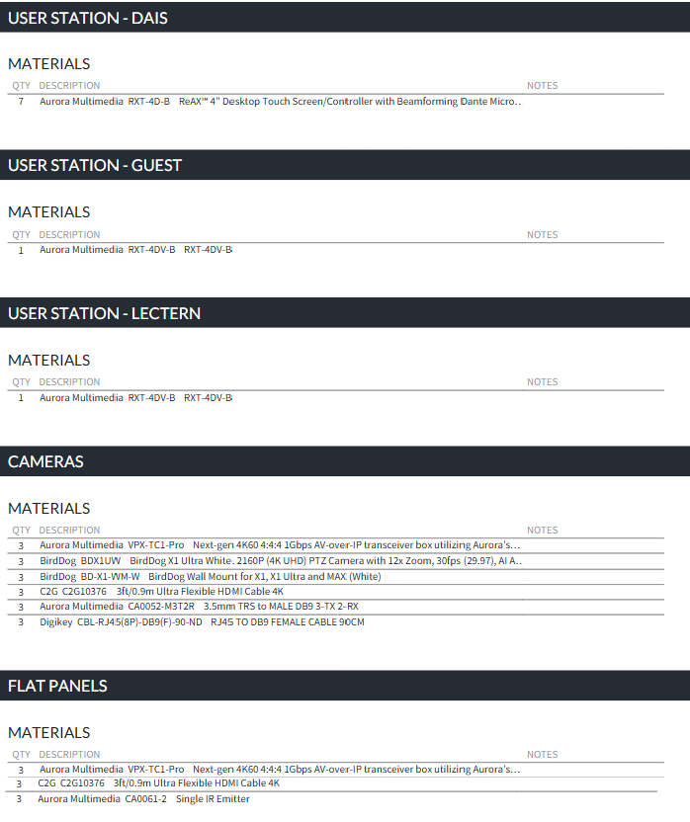

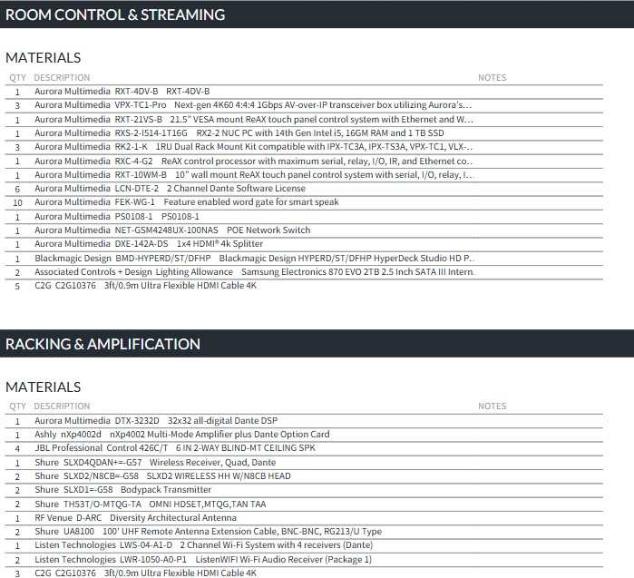
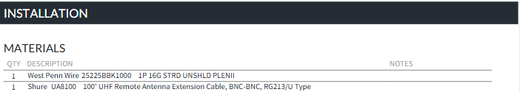

APPENDIX B
USER INTERFACE DESCRIPTION

The Goal of the user interface is to provide the end user with a consolidated system of controls to start and end meeting with as few button clicks as possible from a single operator PC. The room will be programmed to run in three primary modes as well as provide the end user granular controls for meetings that do not fit the three primary environ-ments. The list below is not exhaustive and the programmer is encouraged to add functionality where beneficial.
If a Macro cannot incorporate all functions, the GUI should be arranged to make concurrent control convenient and user friendly.

- Main Launch Screen
  - Council Meeting Auto Start
    - Start Zoom Webinar
    - Start NVR
    - Start Stream
    - Activate Conferencing Mics
      - Auto level
      - Auto gate
    - Activate Room Mics
      - Auto level
      - Auto gate
    - Activate ALS
    - Turn On TVs
    - Cameras to Assigned Presets
  - Floor Meeting Auto Start
    - Start Zoom Webinar
    - Start NVR
    - Start Stream
    - Activate Conferencing Mics
      - Auto level
      - Auto gate
    - Activate Room Mics
      - Auto level
      - Auto gate
    - Activate ALS
    - Turn On TVs
    - Cameras to Assigned Presets
  - Non-Streamed or Recorded Meeting Auto Start
    - Activate Conferencing Mics
      - Auto level
      - Auto gate
    - Activate Room Mics
      - Auto level
      - Auto gate
    - Activate ALS
    - Turn On TVs
    - Cameras to Assigned Presets

- Zoom Control Page
  - Start/Stop
  - Admit/Deny
  - Mic Selection
    - Typically the sum from the DSP
  - Camera Selection
    - Typically the preset that matches room configuration
- NVR Control Page
  - Start/Stop
  - File Management
  - Same as Zoom feed
- Stream Control Page
  - Start/Stop
  - Admit/Deny
  - File Management
  - Same as Zoom feed
- Conferencing Mics Page
  - Auto level
  - Auto gate
  - Chairman Mic configured with override to mute/unmute any participant
  - Control Position configured with override to mute/unmute any participant
  - Manual level adjustments available as required
- Room Mics Page
  - Auto level
  - Auto gate
  - Manual level adjustments available as required
- TV Page
  - Automated
    - Power On/Off
    - Source Selection
  - Manual adjustments available as required
- Camera Page
  - Ability to record/re-record presets
  - Automated Assignment for Main & PIP images
    - To in room TV
    - To Zoom
  - Manual adjustments available as required

APPENDIX C DIVISION OF LABOR

The Installing Contractor shall be responsible for:
- Provide and install all materials listed on AV-101 and in Appendix A - Bill of Materials
- Interface above with Owner Furnished Equipment (OFE)
- Program User Interface (see Appendix B) to achieve desired functionality
  - Provide User Interface Adjustments (Spec 3.4.G.1)
- Provide User Training (Spec 3.4.F.1)

The Owner shall be responsible for:
- Equipment rack(s) as required for system components listed on AV-101 and in Appendix A - Bill of Materials
- CAT# cabling, pathways, boxes, patch bays & terminations as required for system components listed on AV-101
- Qty3 OFE Flat Panels with Mounts

RXT-4D-B

RXT-4D-B

RXT-4D-B
lJ)
RXT-4D-B
�0

RXT-4D-B

RXT-4D-B

RXT-4D-B

Alt
(I')
<[
z

0
0.....
I
X
::,
(X)
v
(\J
v
:::;:
(I')
L:J I
1-
w
z
.'s-::.
u
+-'3:
(I')
□w
Cl..
>

<[

L
cl CIJ CJ)
+'
zCIJ

f<c>oM Co"'lf'g (8 ._,,nits)

VPX-TCl-Pro <END

VPX-TCl-Pro <ENC)

VPX-TCl-Pro <ENC)

HDMI

CA0052-M3T2R CBL-RJ45(8P)-DB9(F)-90-ND

POE & Control

HDMI

CA0052-M3T2R CBL-RJ45(8P)-DB9(F)-90-ND

POE & Control

HDMI

CA0052-M3T2R CBL-RJ45(8P)-DB9(F)-90-ND

POE & Control

HDMI CA0061-2
VPX-TCl-Pro <DEC)

HDMI
VPX- TCl-Pro <DEC)

_J

w
z
<[
.,> Q
I-

-t>
lJ)
(lJ
:::5
l.'.J

RXT-4DV-B
RXT-4D-B

RXT-4D-B

RXT-4::::l B

CA0061-2

HDMI CA0061-2
VPX-TCl-Pro <DEC)
.,>

.,>
<[
_J

LL
(Y)
o_w
>, LL
-PD

-t>
RXT-4DV-B
u
(lJ
_J
GENERAL NOTES

□ □FE Ro.ck
FE Po.tch Bo.ys
□FE L V Co.bles �
T erMino. tions As Required
DATE: 1/21/2026
DRAWN BY: MSG
SHEET #

AV-101

RXT-4D-B
RXT 4D :3

�XT-4D-B
RXT-4DV-B

RXT-10\./M-B

SLXD4QDAN+=-G57 w/ qty2 SLXD2/N8CB=-G58 qty2 SLXD1=-G58
qty2 TH53T/D=MTQG-TA
DTX-3232D

Listen Technologies L\./S-04-Al- D

ASHLY nXp4002d

RXC-4-G2

RXT-21VS-B

Building LAN









Recording Ho.rdwo.re Blo.ckMo.gic Design BMD-HYPERD/ST/DFHP
w/ qty2
So.Msung Electronics
870 EV□
2TB Interno.l SSD (MZ-77E2T0B/AM)
Streo.Ming Ho.rdwo.re
□FE - TBD

Boone County Council Cho.rv-iber AV 8x Video Conferencing Syster-i
MARTY GOLOB 269-223-4407
mgolob@acdtheatrical.com

AcknowledgeMents:
Conceptuo.l Design by Robert Louis Assoc.
Initio.l Dro.wing by NPC

Associated Controls + Design
intelligent lighting + dimming + rigging
6850 N Guion Rd, Indianapolis, IN 46268 T: 877.298.3961 F: 317.293.0281
qty2 UA8100

RF Venue
D-ARC
BUILDING LAN

SYSTEM LAN HDMI CONTROL
SPEAKER

ANTENNA
JBL 426C/T

JBL 426C/T
JBL 426C/T

JBL 426C/T

VPX-TCl-Pro <DEC)

VPX-TCl-Pro <ENC)

VPX-TCl-Pro <DEC)

HDMI
(I')
A I
<[

HDMI

HDMI

HDMI

HDMI
I
w
X A
.v....
(\J

RXS-2-1514-1T16G

