Boone County Area Plan Commission (APC) Meeting Agenda

Lamar Meeting Room - Boone County Government Building September 3, 2025, at 7:00 p.m.
ZOOM LINK- https://zoom.us/j/4874385613 Please make sure your audio is muted.
Call to Order and Pledge of Allegiance Approval of Agenda
Introduction of Board Members

Continued Public Hearings
  - 25WO-7M-091 Elizabeth Carpenter; Minor Residential Subdivision in the Agricultural (AG) District. Continued to confirm drainage outlet.
  - 25SC-7M-120 Lawrence Cammarata; Minor Residential Subdivision in the Agricultural (AG) District. Continued to confirm drainage outlet.
  - 25JE-7M-145 William Riegel/Attorney Michael Andreoli; Minor Residential Subdivision in the Agricultural (AG) District. Continued to confirm drainage outlet.
  - 25WA-16-143 Irving Materials/Attorney Kent Frandsen; Zone Map Change. Continued to resolve compliance with Ordinance requirements.

New Business Public Hearings
  - 25JE-7M-141 John Harrison; Minor Residential Subdivision in the Agricultural (AG) District.
    - Application File
    - Staff Report
  - 25CP-19-169 Declaratory Resolution that RDC’s Economic Development Plan complies with the
Comprehensive Plan
    - Resolution

  - 25ZO-16-168 Zoning Ordinance and Fee Schedule Amendments (Note, Ord 4 – Flag Lots needs further discussion)
    - Ord 1 - Administrative process for considering single-family residential uses in the AG district.
    - Ord 2 - Standards and process for allowing accessory dwelling units.
    - Ord 3 - Standards for PUDs
    - Ord 5 - Town of Advance only: Reducing minimum single-family home sizes
    - Ord 6 - Fee Schedule
    - Public Comment on draft ordinances

Violations Report
None at this time.

Approval of Minutes
  - May 7, 2025
  - May 21, 2025 (Special Meeting)
  - July 2, 2025
  - August 6, 2025

Administrative Matters
  - Discussion of Inter-local agreement for providing planning and/or building inspection services to municipalities in Boone County.
  - Discussion of regulating Flag Lots

Adjournment
Agenda is subject to change.
*Public Testimony: any written comments or objections to the proposals that are filed with the Area Plan Commission office before the hearing will be considered. Any oral comments concerning the proposals will be heard by the APC at the hearing. In addition, the hearing may be continued from time to time by the APC, as it may be found necessary.
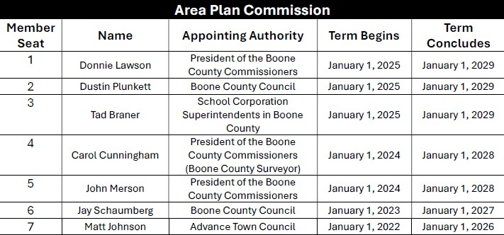
The Boone County Area Plan Commission acknowledges its responsibility to comply with the American Disabilities Act of 1990. In order to assist individuals with disabilities who require special services (i.e. sign interpretative services, alternate audio/visual devices, and amanuenses) for participation in or access to county sponsored public programs, services and or meetings, the county request that individuals make request for these services forty-eight (48) hours ahead of the scheduled program, services and/or meeting. To make arrangements, contact Ashley Elliott, Administrative Assistant, at (765) 482-3821.

