Boone County Board of Zoning Appeals (BZA)
May 28, 2025, at 7:00 PM
Lamar Meeting Room - Boone County Government Building

Members Attending: Brent Henschen, Jay Schaumberg and John Merson

Members Absent: Danielle Morrison

Staff Attending: Deborah Luzier (Planning Director), Ashley Elliott (Administrative Assistant) and Bob Clutter (Attorney for the Boone County BZA and APC)

Participants Who Attend on Zoom:
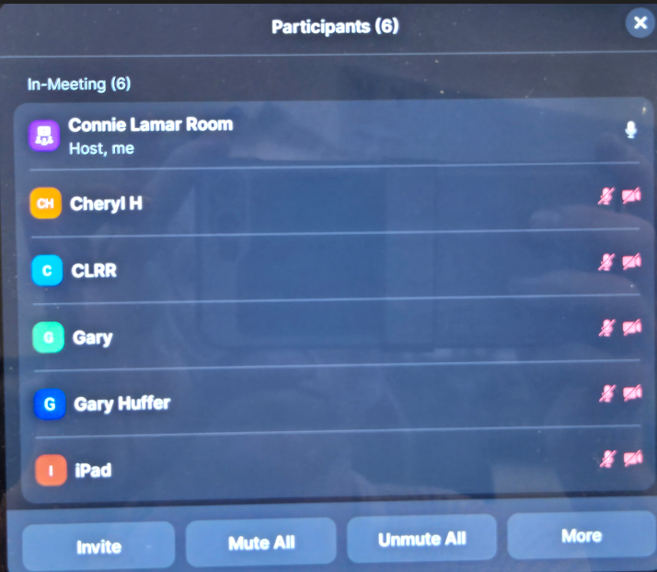

A. Administrative Issues
1. John Merson opened the meeting at 7:00 pm by leading the Pledge of Allegiance.
Introductions followed.

2. Determination of Quorum: 3 of 4 members present.

3. Approval of Minutes for April 23, 2025, meeting:
Brent Henschen made a motion to approve the minutes from April 23, 2025.
Jay Schaumberg seconded the motion. Motion carried 3-0.

4. Approval of the Agenda:
None at this time.

B. Old Business Public Hearings:
None at this time.

C. New Business Public Hearings:
1. 25MA-7V-073 John and Kendra Chastain; Special Exception to allow a residence in the Agriculture (AG) district as well as a variance to reduce 40 feet to 10 feet to accommodate a legal non-conforming accessory structure
Deborah Luzier read the staff report.
Kendra Chastain came forward on behalf of this petition. No one else came forward.
John Merson closed the public hearing and opened it to the board. Jay Schaumberg asked what the size of the property was, and the answer was 4.3 acres.
Brent Henschen made a motion to approve 25MA-7V-073 with the conditions stated in the staff report.
Jay Schaumberg seconded the motion. Motion carried 3-0.

2. 25HA-14-053 Christopher Elett; Variance to reduce the required setback from 40 feet to 22 feet and 16 feet for the purpose of constructing an accessory structure
Deborah Luzier read the staff report.
Christopher Elett came forward on behalf of this petition. He wanted to mention the site plan only shows 4 fingers for his septic, but it has 5 fingers. No one else came forward.
John Merson closed the public hearing and opened it to the board. Jay Schaumberg asked if this structure is for additional storage and will not be any dwelling in it for a residence. Mr. Elett replied no it’s just for storage. Jay Schaumberg wanted to confirm that since this would be set up completely for dwelling there would be no residence and then Bob Clutter said no the septic is just for the primary residence.
Brent Henschen made a motion to approve 25HA-14-053 with the conditions stated in the staff report.
Jay Schaumberg seconded the motion. Motion carried 3-0.

3. 25WA-14-076 Zachary Weber; Variance to expand a legal non-conforming accessory structure as well as allow the cumulative area of all accessory structure to exceed 75% of building footprint of the primary structure
Deborah Luzier read the staff report.
Zachary Weber came forward on behalf of this petition. No one else came forward.
John Merson closed the public hearing and opened it to the board. No questions or issues were raised by Board Members.
Jay Schaumberg made a motion to approve 25WA-14-076 with the conditions stated in the staff report.
Brent Henschen seconded the motion. Motion carried 3-0.

4. 25SC-7-078 Tim Secrist; Special Exception to allow a residential use in the Agricultural (AG) zoning district
Deborah Luzier read the staff report.
Tim Secrist came forward on behalf of this petition. No one else came forward.
John Merson closed the public hearing and opened it to the board. No questions or issues were raised by Board Members.
Jay Schaumberg made a motion to approve 25SC-7-078 with the conditions stated in the staff report.
Brent Henschen seconded the motion. Motion carried 3-0.

5. 25WA-14-079 Thorntown Veterinary Clinic; Variance to expand a non-conforming use as well as variances from the development standards of the Major Thoroughfare Overlay District
Deborah Luzier read the staff report.
John Culbertson came forward on behalf of this petition.
John Merson closed the public hearing and opened it to the board. Jay Schaumberg asked why the Highway Department is requesting them to use the existing driveway off 500 yet requiring a new driveway permit. Deborah Luzier responded because it would be accessed off a different and the proposed area is coming up all the way to the street and they want it pulled back a little bit so that you must enter through a driveway to get to the parking area. No one else came forward.
John Merson closed the public hearing and opened it to the board. Jay Schaumberg stated he is good with it even though it doesn’t comply with the Overlay, but they have already been established there. Bob Clutter stated yes that it is a pre-existing non-forming use.
Brent Henschen made a motion to approve 25WA-14-079 with the conditions stated in the staff report.
Jay Schaumberg seconded the motion. Motion carried 3-0.

D. Reports, Resolutions, Communication & General Discussion

- Director’s Announcements:
Deborah Luzier wanted to note about a call that grain bins are blocking their Wi-Fi.

With no further business, Brent Henschen made a motion to adjourn at 7:29pm.
Jay Schaumberg seconded the motion. Motion carried 3-0.

