BOONE COUNTY, INDIANA TITLE VI
NONDISCRIMINATION IMPLEMENTATION PLAN & POLICY

TABLE OF CONTENTS

Policy Statement Page 95
- Title VI Coordinator Page 95
- Employer/Employee Dissemination &Training Page 96
- Contractors, Subcontractors, Consultants & Vendors… Page 97
- Concerns/Complaint Process… Page 97
- Public Dissemination Page 99
- Community Involvement & Outreach Page 99
- Data Collection Page 99
- Limited English Proficiency (LEP) Plan Page 100
- Appendix A-I-Speak Cards… Page 104
- Appendix B-Complaint Policy… Page 108
- Appendix C-Complaint Log… Page 110
- Appendix D-External Complaint Form Page 111

BOONE COUNTY, INDIANA
TITLE VI NONDISCRIMINATION PLAN & POLICY

- POLICY STATEMENT

Title VI of the Civil Rights Act of 1964, as amended, prohibits discrimination on the basis of race, color, or national origin in programs and activities receiving Federal financial assistance. Specifically, Title IV provides that “no person in the United States shall, on the ground of race, color, or national origin, be excluded from participation in, be denied the benefits of, or be subjected to discrimination under any program or activity receiving Federal Financial
Assistance” (42 U.S.C. Section 2000d).

Pursuant to Title VI of the Civil Rights Act of 1964, as amended, and the Civil Rights Restoration Act of 1987, Boone County, Indiana, hereinafter referred to as “Boone County,” will not exclude from participation in, deny the benefits of, or subject to discrimination any individual on the grounds of race, color, or national origin, sex, age, disability, limited English proficiency and income status.
- TITLE VI COORDINATOR

Megan Smith
HR Director

116 West Washington Street, Room 104
Lebanon, IN 46052
Phone: 765-535-7518
Fax 765-483-4494
E-mail: megsmith@co.boone.in.us

The Boone County Title VI Coordinator will:
-Administer and implement Boone County’s Title VI plan and policy.
-Develop and maintain a Title VI liaison team (Appendix D) to ensure departments are
implementing, monitoring and complying with Boone County’s Title VI plan and policy
-Conduct Title VI yearly reviews with liaisons in an effort to assist with identifying, addressing and eliminating discrimination concerns in every department.
-Conduct or facilitate Title VI training programs with department liaisons for dissemination to employees.
-Work with liaisons to develop and disseminate Title VI information to contractors, subcontractors, vendors and consultants.
-Ensure Title VI language is included in Boone County contracts
-Collect, review and preserve statistical data (race, color, national origin, language, gender, etc.) of participants in activities and programs to ensure Boone County’s continued compliance with Title IV.
-Collect, review and preserve data regarding the number of federally funded projects awarded or ongoing for the past three (3) years.
-Maintain all Title VI records and correspondence, including but not limited to, signed employee acknowledgements, complaints and all correspondence regarding such, requests for language services, demographic statistics, department compliance reviews and all Title VI federal agency correspondence and records.
-Address all Title VI discrimination complaints.
-Review and update the Title VI plan and policy as needed or required.
-Prepare and submit the annual Title VI update report.

- EMPLOYER/EMPLOYEE DISSIMENATION & TRAINING
Title VI plan and policy education and literature will be provided to all Boone County employees. Boone County Employees will be required to sign an acknowledgement form indicating they have received and reviewed Title VI policy guidelines. New Employees will be provided and education and literature at new employee orientation. Employees will be provided with updated education and literature as Boone County deems necessary.

Employees will be expected to follow the Title VI policy and the guidelines set forth. In addition, Boone County employees should make every effort to alleviate any barriers to service or public use that would restrict public access or usage, take prompt and reasonable action to avoid or minimize discrimination incidences and immediately notify the Title VI Coordinator, in writing, of any questions, complaints or allegations of discrimination.

- CONTRACTORS, SUBCONTRACTORS, VENDORS & CONSULTANTS
All contractors, subcontractors and vendors who receive payments from Boone County where funding originates from any Federal assistance programs are subject to the provisions of Title VI of the Civil Rights Act of 1964, as amended. Boone County will include Title VI language, as per the Standard U.S. DOT Title VI Assurances. Written agreements relevant to Title VI shall not contain any form of discrimination, either written or implied.

- CONCERNS/COMPLAINT PROCESS
Boone County will take prompt and reasonable actions to thoroughly investigate concerns and complaints. Any individual, who believes they have been subjected to discrimination, may file a complaint with the Boone County Title VI Coordinator. Complaint Forms can be found on Boone County’s website: www.boonecounty.in.gov, or by contacting the Boone County Title VI Coordinator or Human Resources Director. In order for the complaint to be considered, the complainant must file the appropriate documentation:
- Within 180 days of the alleged act of discrimination; or
- Where there has been a continuing course of alleged discriminatory conduct, on the date in which the alleged conduct was discontinued.

Complaints shall be made in writing and shall be signed by the complainant and/or the complainant’s representative. Complaints must contain the following and describe as completely as possible the facts and circumstances surrounding the alleged discrimination:
-Name of the complainant.
-Contact information (telephone number, address, email address).
-Basis for the allegation(s) (i.e., race, color, national origin, gender, age, etc.).
-A detailed description of the alleged discrimination (how, when, where, why they believe they were discriminated against including the location(s), name(s) and contact information of all witnesses, if applicable).
-Any other information that is deemed significant.
If the complainant is unable or incapable of providing a written statement, a verbal complaint may be made to the Boone County Title VI Coordinator. Under these circumstances, the complainant will be interviewed and the Boone County Title VI Coordinator will assist the complainant in completing a written statement.
Within fifteen (15) calendar days after receipt of the complaint, the Title VI Coordinator will arrange to speak or meet with the complainant to discuss the complaint and the possible resolution if applicable. If a complaint is deeded incomplete, additional information will be requested. The complainant has sixty (60) business days to respond to the request for
additional information. A complainant’s failure to respond to the request within sixty (60) business days may result in the administrative closure of the complaint.

If Boone County Does not have sufficient jurisdiction to investigate the complaint, the Title Vi Coordinator will refer the complaint to the appropriate local, state or federal agency holding such jurisdiction. The Title VI Coordinator will notify the complainant or their representative, in writing, that the complaint is outside of Boone County’s jurisdiction and where the complaint has been referred for further handling.

The Title VI Coordinator will conduct a complete and thorough investigation of complaints
inside Boone County’s jurisdiction and based upon the information obtained will render a final written response letter to the complainant or their representative by registered mail or hand delivery within sixty (60) business days. The final written response will include a description of the complaint, a summary of the investigation and the findings of such, summaries of all individuals interviewed, and if appropriate, recommendations and resolutions. All written complaints, investigations and responses will be retained by Boone County for at least three (3) years.
A complainant’s identity shall be kept confidential except to the extent necessary to complete the investigation. If it is necessary to disclose the complainant’s identity to the alleged person who may have discriminated or a third-party, Boone County must first obtain the
complainant’s written consent. Boone County must also obtain the complainant’s written consent before providing a copy of the complaint to any other individual(s) involved with the investigation.
If a complainant is dissatisfied with the final resolution of the compliant, they have the right to file a complaint with:
Department of Justice
Federal Coordination and Compliance Section-NWB Civil Rights Division
U.S. Department of Justice
950 Pennsylvania Avenue, N.W. Washington, D.C. 20530

- PUBLIC DISSEMINATION
Title VI information shall be displayed in Boone County buildings and all places in which public meetings are held. The name and contact information of the Boone County Title VI Coordinator will be displayed on the Title VI information.

The Boone County Title VI plan and policy, which includes the ADA/Section 504 plan, Limited English Proficiency (LEP) plan and complaint procedures, is available on the Boone County website at www.boonecounty.in.gov Copies of any of these plans will be provided upon request. LEP individuals may obtain translated copies of these plans upon request. Any questions or comments regarding this plan should be directed to the Title VI Coordinator.

- COMMUNITY INVOLEMENT & OUTREACH
Boone County is committed to ensuring the community involvement and outreach is done in a respectful and appropriate manner that will allow for diverse involvement. Public meetings, programs and activities will provide equitable opportunities for participation.

The Boone County Council and the Boone County Board of Commissioners meet monthly and those meetings are open to the public, as well as other various Boone County meetings. Any meetings that are open to the public are published on the Boone County website’s main page and distributed to local media outlets. All Boone County public meetings are held in locations accessible to individuals with disabilities. Upon request, translators can be provided free of charge to those individuals with limited English proficiency. Auxiliary aids are also available upon request. Request must be made within forty-eight (48) hours in advance.

Also published on the Boone County website are various meeting agenda’s, meeting minutes, Boone County notices, events and news. Some departments within Boone County utilize signage, media and social media websites as another avenue to communicate with the community.
- DATA COLLECTION
Pursuant to 23 CFR 200.9 (b) (4), Boone County shall collect and analyze statistical information regarding demographics to assist in monitoring and ensuring nondiscrimination in all of its programs and activities.

Boone County shall utilize a voluntary Title VI public involvement survey that will be available at all public hearings and meetings. The survey will allow respondents to remain anonymous. The survey will ask questions regarding the respondent’s gender, ethnicity, race, age, income and if they are disabled.

The facilitator of the public hearings and meetings will make an announcement at the beginning
informing attendees of the survey and its purpose and a request will be made for the attendees to complete the voluntary survey. Completed surveys will be retained by the Title VI Coordinator for three (3) years.

The Title VI Coordinator will also collect and report statistical data for the past three (3) years as it relates to the number of federally funded projects, complaints filed and the results of those complaints, any requests for language services, demographic statics and department compliance reviews.

SECTION 504/AMERICANS WITH DISABILITIES (ADA)
Pursuant to the requirements of Section 504 of the Rehabilitation Act of 1973 (29 U.S.C 794) as amended, and the Americans with Disabilities Act of 1990, as well as any other local, federal and state laws and regulations, Boone County will make every reasonable effort to ensure that no individual with a disability will be excluded from the participation in, be denied the benefits of, or be subjected to discrimination under any of Boone County’s programs or activities.

For more information regarding Boone County’s ADA please visit Boone County’s website at www.boonecounty.in.gov and select the ADA Documents Tab to view the Boone County’s ADA Transition Plan and compliance statement. ADA complaint forms can also be obtained on Boone County’s website or by contacting the Boone County ADA Coordinator or the Human Resources Consultant hired by County Commissioners.

Questions, concerns, comments or requests regarding ADA should be made to Boone
County’s ADA officer:
Max Mendenhall
Director of Capital Investments
127 W. Main Street
Lebanon, IN 46052

LIMITED ENGLISH PROFICIENCY (LEP) PLAN
Boone County has prepared this plan in accordance with Title VI of the Civil Rights Act of 1964, as amended, which states that no person shall be subjected to discrimination on the basis of race, color or national origin. The purpose of this plan is to help identify reasonable steps for providing language assistance to individuals with limited English proficiency who wish to access services provided by Boone County.
Presidential Executive Order No. 13166, titled “Improving Access to Services for Persons with Limited English Proficiency,” indicates that individuals treated differently based upon their inability to speak, read write or understand English is a type of national origin discrimination. Presidential Executive Order 13166 defines limited English proficiency persons as those individuals who do not speak English as their primary language and have limited ability to read, speak, write or understand English.

In order to prepare this plan, Boone County utilized the U.S. Department of Transportation four-factor LEP analysis which considers the following factors:

The number or proportion of LEP persons in the service area who may be served or are likely encounter a Boone County program, activity or service.

The frequency with which LEP persons come in contact with Boone County programs activities or services.

The nature and importance of programs, activities or services provided by Boone County to the LEP population.
The resources available to Boone County and the overall costs to provide LEP assistance.

TITLE VI ASSURANCES

Boone County (hereinafter referred to as the “Recipient”) HEREBY AGRESS THAT as a condition to receiving any Federal financial assistance from the Department of Transportation it will comply with Title VI of the Civil Rights Acts of 1964, 78 Stat. 252, 42 U.S.C. 2000d-42 U.S.C.
200d-4 (hereinafter referred to as the “Act”), and all requirements imposed by or pursuant to Title 40, Code of Federal Regulations, Department of Transportation, Sub Title A, Office of the Secretary, Part 21, Nondiscrimination in Federally-Assisted Programs of the Department of Transportation-Effectuation of Title VI of the Civil Rights Act of 1964 (hereinafter referred to as the “Regulations”) and other pertinent directives, to the end that is in accordance with the Act, Regulations, and other pertinent directives, no person in the United States shall, on the grounds of race, color, or national origin, be excluded from participation in, be denied the benefits of, or be otherwise subjected to discrimination under any program or activity for which the Recipient receives Federal financial assistance from the “appropriate Grantor(s)” and, HEREBY GIVES ASSURANCE THAT it will promptly take any measure necessary to effectuate this agreement.
This assurance is required by subsection 21.7(a)(1) of the Regulations.
More specifically and without limiting the above general assurance, the Recipient hereby gives
the following specific assurances with respect to the “appropriate Grantor(s):”

That the Recipient agrees that each “program” and each “facility” as defined in
subsections 21.23(e) and 21.23(b) of the Regulations, will be (with regard to a
“program”) conducted, or will be (with regard to a “facility”) operated in compliance
with all requirements imposed by, or pursuant to, the Regulations.
  - That the Recipient shall insert the following notification in all solicitations for bids for work or material subject to the Regulations and made in connection with the “appropriate Grantor(s)” and, in adapted form in all proposals for negotiated agreements:

Recipient, in accordance with Title VI of the Civil Rights Act of 1964, 78 Stat, 252, 42 U.S.C. 2000d to 2000d-4 and Title 49, Code of Federal Regulations, Department of Transportation, Sub Title A, Office of the Secretary, Part 21, Nondiscrimination in Federally assisted programs of the Department of Transportation issued pursuant to such Act, hereby notifies all bidders that it will affirmatively insure that in any contract entered into pursuant to this advertisement, minority business enterprises will be afforded full opportunity to submit bids in response to this invitation and will not be discriminated against on the grounds of race, color, or national origin in consideration for an award.

  - That the Recipient shall insert the clauses of Appendix A of this assurance in every contract subject to the Act and the Regulations.
  - That the Recipient shall insert the clauses of Appendix B of this assurance as a covenant running with the land, in any deed from the United States effecting a transfer of real property, structures, or improvements thereon, or interest therein.
  - That where the Recipient receives Federal financial assistance to construct a facility, or part of a facility, the Assurance shall extend to the entire facility and facilities operated in connection therewith.
  - That where the Recipient receives Federal financial assistance in the form, or for the acquisitions of real property or an interest in real property, the Assurance shall extend to rights to space on, over or under such property.

This Assurance is given in consideration of and for the purpose of obtaining any and all Federal grants, loans, contracts, property, discounts or other Federal financial assistance extended after the date hereof to the Recipient Department of Transportation under the “appropriate Grantor(s)” and is binding on it, other recipients, sub-grantees, contractors, subcontractors, transferees, successors in interest and other participants in the “appropriate Grantor(s)”. The person or persons whose signatures appear below are authorized to sign this Assurance on behalf of the Recipient.

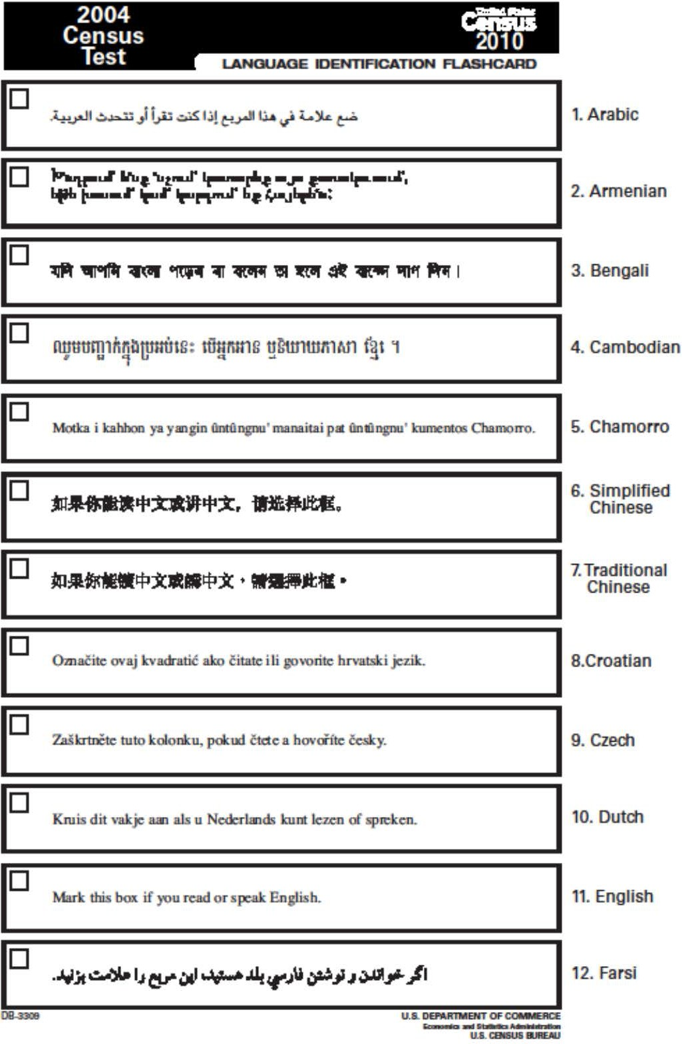

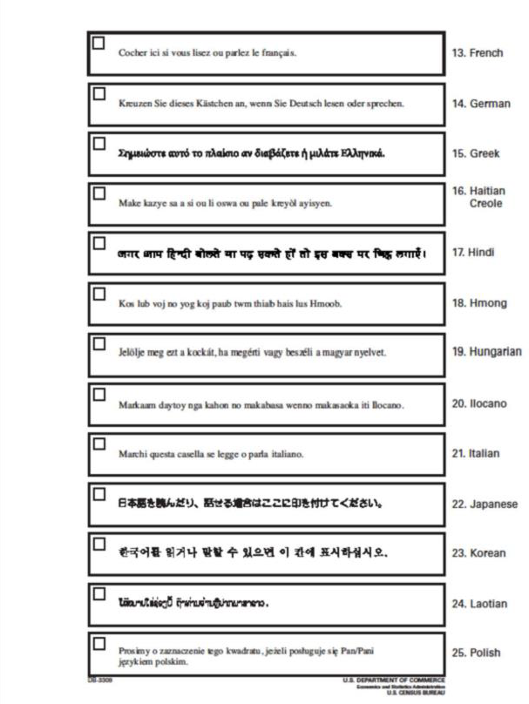

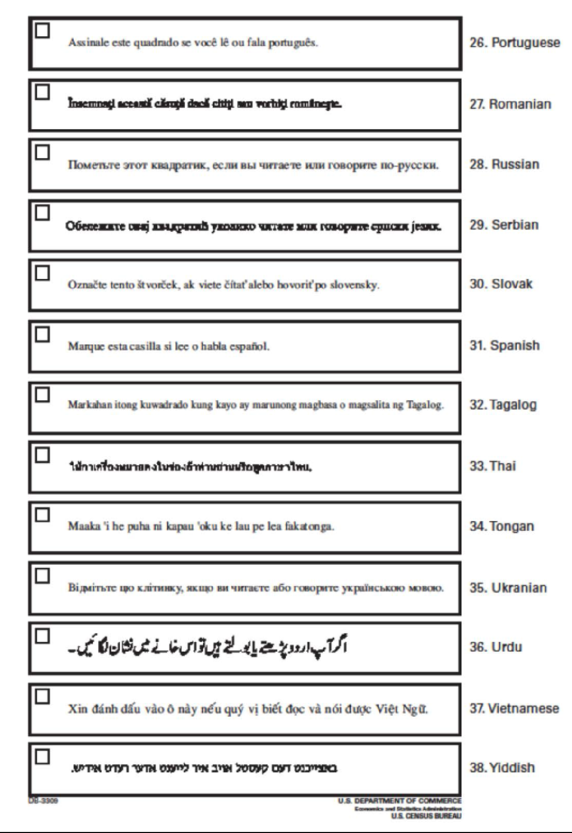

Appendix B-Complaint Policy

Any person who believes that he or she as a member of a protected class, has been discriminated against based on race, color, national origin, gender, age, disability, religion, low income status, or Limited English Proficiency in violation of Title VI of the Civil Rights Act of 1964, as amended and its related statutes, regulations and directives, Section 504 of the Vocational Rehabilitation Act of 1973, Americans with Disabilities Act of 1990, as amended, the Civil Rights Restoration Act of 1987, as amended, and any other Federal nondiscrimination statute may submit a complaint. A complaint may also be submitted by a representative on behalf of such a person.
It is the policy of Boone County to conduct a prompt and impartial investigation of all allegations of discrimination and to take prompt effective corrective action when a claim of discrimination is substantiated.
No one may intimidate, threaten, coerce or engage in other discriminatory conduct against anyone because they have taken action or participated in an action to secure rights protected by the civil rights laws. Any individual alleging such harassment or intimidation may submit a complaint by following the procedure printed below.
Any individual who feels that he or she has been discriminated against may submit a written or verbal complaint. The complaint may be communicated to any supervisor or to the Boone County Title VI Coordinator or Boone County Human Resources. The complaint should be submitted within 180 days of the alleged discrimination. Complaint forms may be found in the Office of the Title VI Coordinator or Boone County Human Resources. Individuals are not required to use the County’s complaint form. If necessary, the company will help an individual reduce his or her complaint to writing for his or her signature.
Generally a complaint should include the name, address and telephone number of the individual complaining (complainant) and a brief description of the alleged discriminatory conduct including the date of harm. An individual submitting a complaint alleging discrimination may include any relevant evidence, including the names of witnesses and supporting documentation.
Complaints should be directed to: MEGAN SMITH, TITLE VI COORDINATOR 116 WEST WASHINGTON STREET, SUITE 104
LEBANON, IN 46052
TELEPHONE: 765-535-7518
FACSIMILE: 765-483-4494
EMAIL: megsmith@co.boone.in.us

Within 60 days of the receipt of the complaint, Boone County will conduct an investigation of the allegation based on the information provided and issue a written report of its findings to the complainant. The Boone County will try to obtain an informal voluntary resolution to all complaints at the lowest level possible. A complainant’s identity shall be kept confidential except to the extent necessary to conduct an investigation. All complaints shall be kept confidential.

These procedures do not deny the right of any individual to file a formal complaint with any government agency or affect an individual’s right to seek private counsel for any complaint alleging discrimination.
Complaints may also be filed with the following government agencies: Indiana Department of Transportation
Economic Opportunity Division 100 N. Senate, Room N750 Indianapolis, IN 46204
Phone: (317) 233-6511
Fax: (317) 233-0891

Indianapolis District EEOC Office 101 West Ohio Street, Ste 1900
Indianapolis, IN 46204
Phone: (800) 669-4000
Fax: (317) 226-7953
TTY: 1 (800) 669-6820

Indiana Civil Rights Commission 100 N. Senate Ave., Room N103 Indianapolis, IN 46204
Toll Free: 1 (800) 628-2909
Phone: (317) 232-2600
Fax: (317) 232-6560
Hearing Impaired: 1 (800) 743-3336

Appendix C: Complaint Log

TITLE VI COMPLAINT LOG

Case No. | Investigator | Complainant | Sub- recipient | Protected Category | Date Filed | Date of Final  Report | Deposition

Appendix D: External Complaint Form
EXTERNAL COMPLAINT OF DISCRIMINATION INSTRUCTIONS:

The purpose of this form is to help any person interested in filing a discrimination complaint with Boone County. You are not required to use this form. You may write a letter with the same information, sign it, and return it to the address below. All bold items must be completed for your complaint to be investigated. Failure to provide complete information may impair the investigation of your complaint.

Title VI of the Civil Rights Act of 1964, as amended and its related statutes and regulations (Title VI) prohibit discrimination on the basis of race, color, national origin, sex, age, disability/handicap, or income status in connection with programs or activities receiving federal financial assistance for the United States Department of Transportation, Federal Highway Administration, and/or Federal Transit Administration. These prohibitions extend to Boone County as a sub-recipient of federal financial assistance.

Upon request, assistance will be provided if you are an individual with a disability or have limited English proficiency. Complaints may also be filed using alternative formats such as computer disk, audiotape, or Braille.

You also have the right to file a complaint with other state or federal agencies that provide federal financial assistance to Boone County. Additionally, you have the right to seek private counsel.

Boone County is prohibited from retaliating against any individual because he or she opposed an unlawful policy or practice, filed charges, testified, or participated in any complaint action under Title VI or other nondiscrimination authorities.

Please make a copy of your complaint form for your personal records. Do not send your original documents as they will not be returned. Mail the original complaint form along with any copies of documents or records relevant to your complaint to the address below.

Complaints of discrimination must be filed within 180 days of the date of the alleged discriminatory act. If the alleged act of discrimination occurred more than 180 days ago, please explain your delay in filing this complaint.

**Your complaint cannot be processed without your signature.

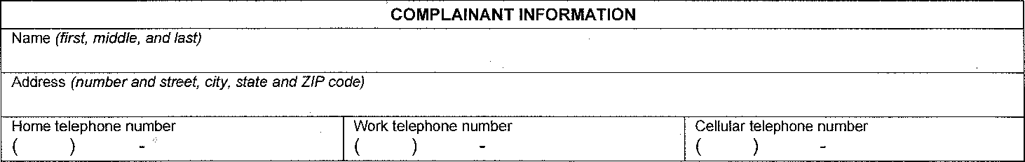
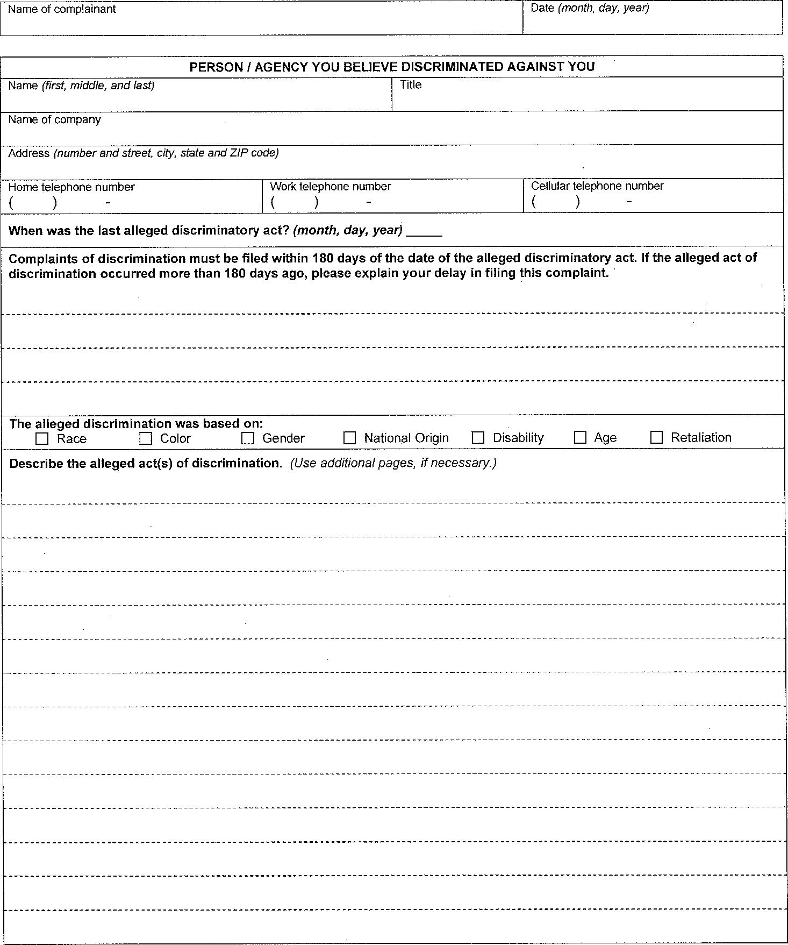
External Complaint Form
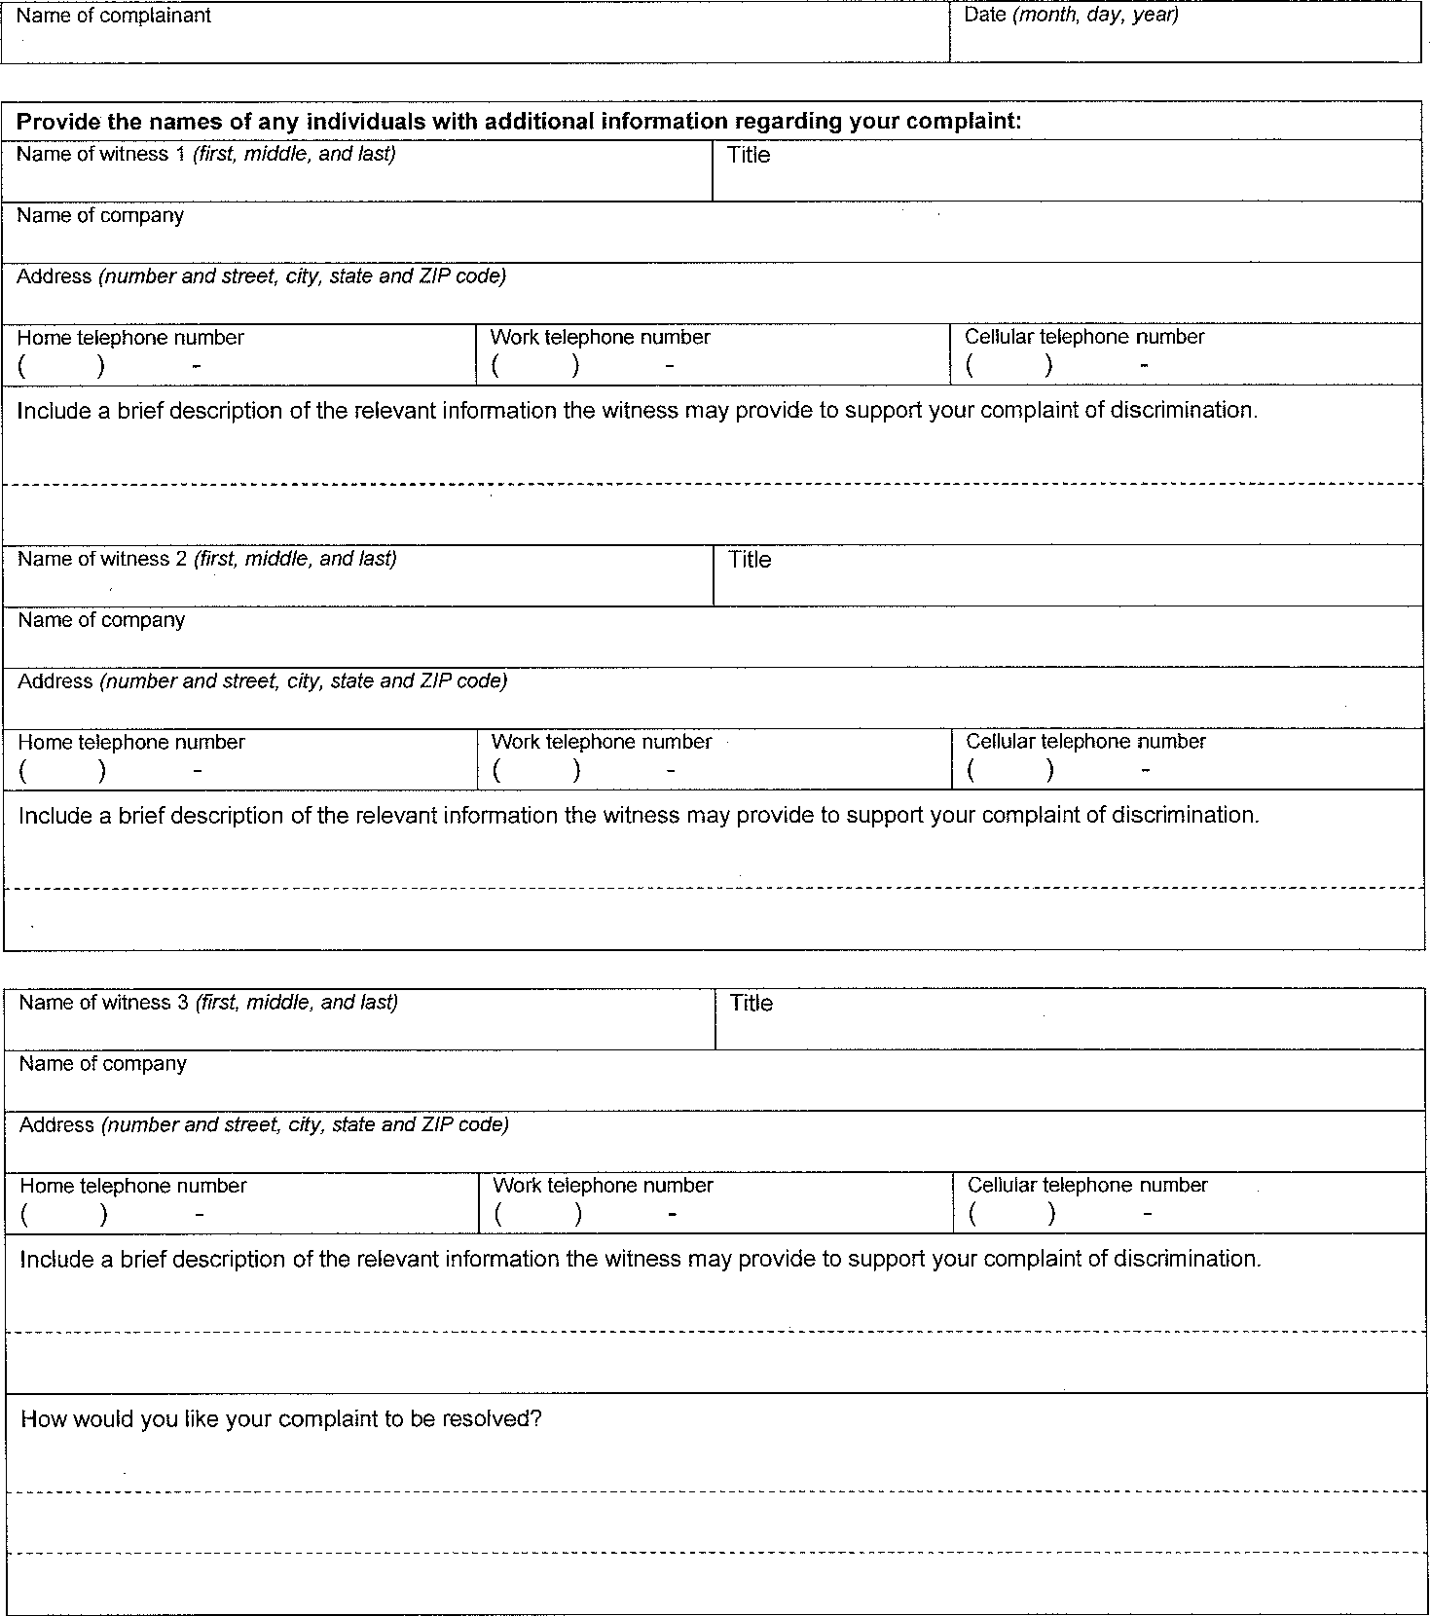

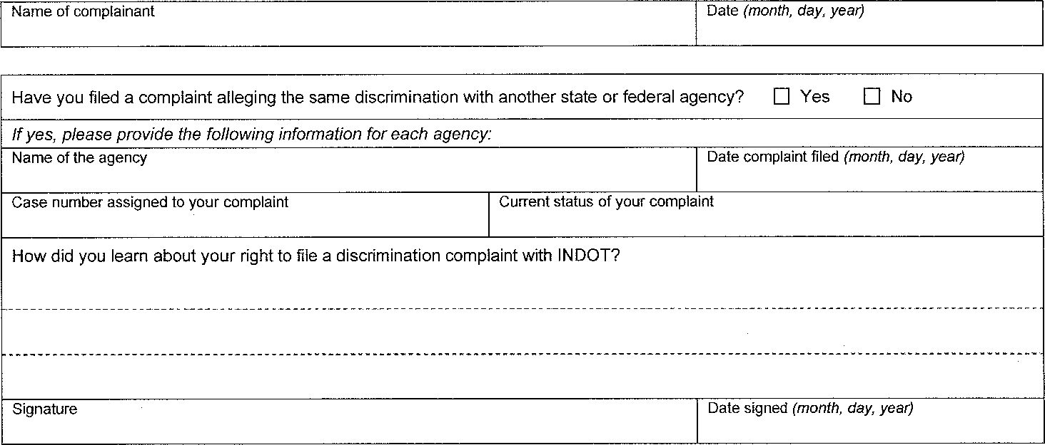

114

