Environmental Division
Suite B201
(765) 483-4458
(765) 483-5243 Fax

_____________
Nursing & Vital Records Division
Suite B202
(765) 482-3942
(765) 483-4450 Fax

Boone County Health Department
116 W. Washington Street - Lebanon, IN 46052
www.boonecounty.in.gov/health

Mobile Food Unit

Application

Requirements and guidelines for submitting a mobile food unit application for license.

Follow these steps when starting a new mobile operation or renovating an existing mobile operation in Boone County:

- Find a Commissary kitchen, or base of operation. Food sold or given away to the public must be prepared and stored in an approved facility. In addition, the vehicles or carts used in the sale of those foods must be serviced at an approved facility each day they operate. This commissary kitchen will be subject to approval.

- Obtain all required City vendor permits, licenses, tax documents etc...

  - Hot Dog carts and Prepackaged Ice Cream carts should contact the Department of Business and Neighborhood Services and obtain zoning restrictions, lottery information etc…

- Complete the Mobile Retail Food Unit Application and submit it along with all the required documents listed under the requirements page of this form.

  - The entire process may take up to 30 business days to complete. We will remain in contact throughout the process with any questions we may have regarding the plan. Additional information and instructions will be provided at the end of the plan review process including instructions for obtaining a pre-licensing appointment.

  - An invoice will be provided after the successful completion of the inspection. Fees are due in full the day of the inspection payable by check, cash or money order.

Licensing Costs:

Mobile Prepackaged - 50.00
Mobile Cook/Serve - 140.00

Mobile Plan Review - 150.00

Note: Your operation may be required to obtain and provide proof of a Certified Food Handler (Food Manager) Certificate in accordance with 410 IAC 7-22. Please visit: http://www.state.in.us/isdh/21059.htm for additional information.

Thank you for your cooperation.

Revised 01/2018

Instructions for submittal

Food Truck/Trailers/ Full Service Ice Cream Trucks

- The following documents must be turned in with each application:
  - Completed questionnaire

  - 1 Extended menu (including toppings, condiments etc..)

    - Menu should indicate all food items which will be cooked to order (i.e. Medium rare etc..)

  - 1 Floor plan drawn to scale (see examples below)

  - 1 Plumbing diagram (see example below)

  - 1 Completed Commissary Agreement

Hot Dog Carts/ Prepackaged Ice Cream Carts, Trucks/Frozen-Prepackaged Meat Trucks

- Hot Dog Carts- The Following documents must be turned in with each application:
  - Completed questionnaire

  - 1 Extended menu (including toppings, condiments etc..)

  - 1 Overhead floor plan or pictures showing all available equipment

  - 1 Completed commissary agreement

- Prepackaged Ice Cream Carts/Truck -The Following documents must be turned in with each application:
  - Completed questionnaire(if applicable)
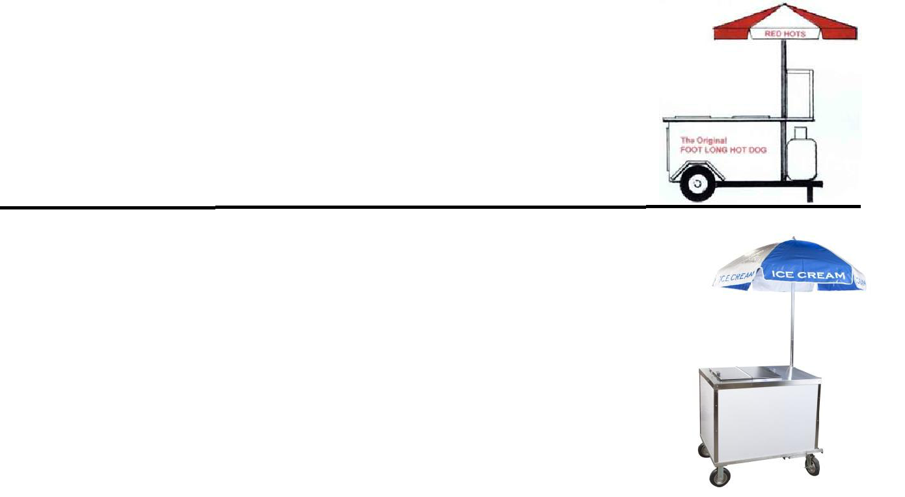

    - If the menu consists of prepackaged ice cream only, please indicate this on the questionnaire and leave the questions blank.

  - 1 Overhead floor plan or pictures of the cart showing all available equipment

  - 1 Completed commissary agreement

- Frozen-Prepackaged Meat Trucks- The Following documents must be turned in with each application:
  - Completed questionnaire(if applicable)

    - If the menu consists of frozen -prepackaged meats only, please indicate this on the questionnaire and leave the questions blank.
  - 1 Overhead floor plan or pictures of the vehicle showing all available equipment

  - 1 Completed commissary agreement

**Below are examples of acceptable floor plans and plumbing diagrams**
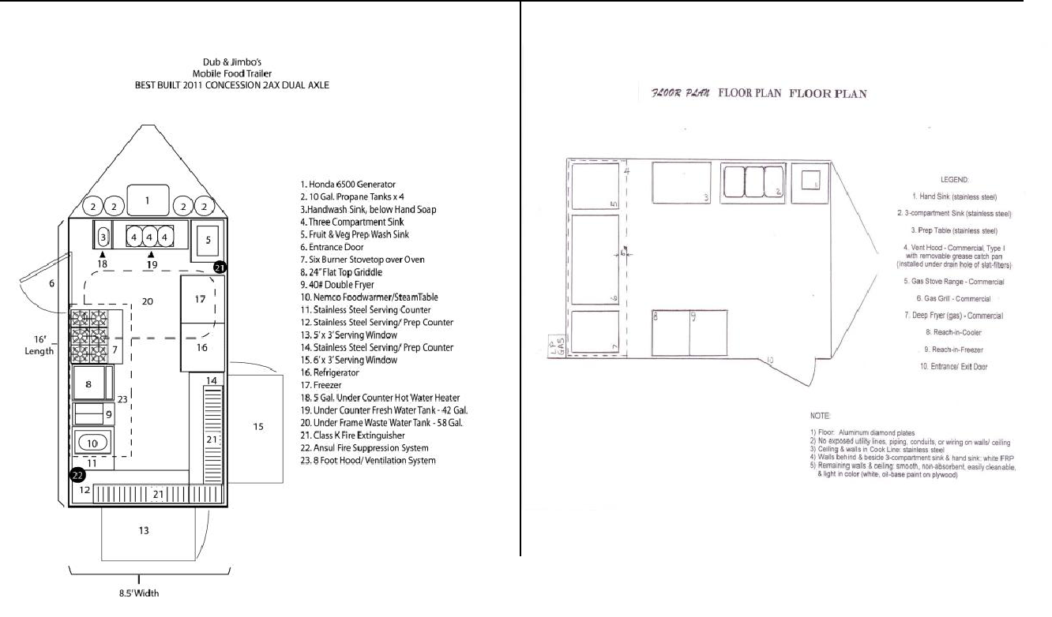

Example Overhead Plan with Legend |  | Example Overhead Plan with Legend

The legends

shown on the

sample floor

plans do not

represent the

actual

requirements.
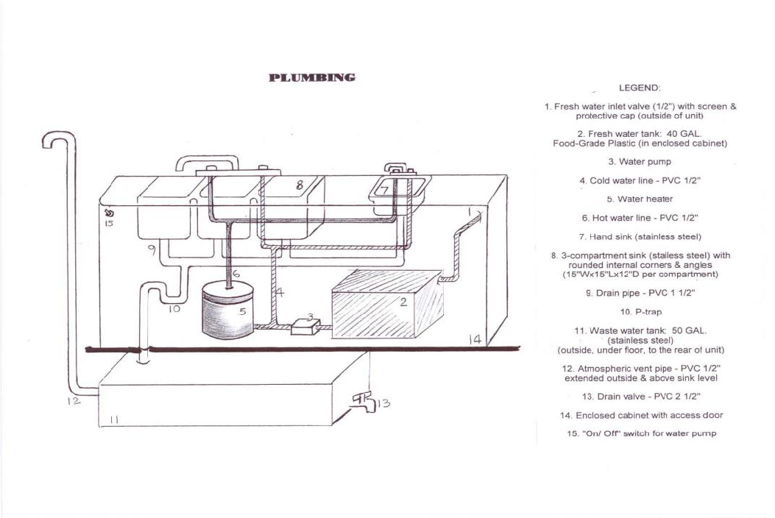

Example Plumbing Plan with Legend

Note: The Potable water system must be completely enclosed from the Inlet valve to the discharge outlet.

CRITERIA FOR NEWLY CONSTRUCTED MOBILE FOOD UNITS

- EQUIPMENT

  - UTENSIL SINK: A 3-compartment stainless steel sink with an integral drain board on each end. This sink must meet current National Sanitation Foundation (NSF) standards. This sink is required if any utensils or pans are used in the food unit. Each compartment should be large enough to submerge the biggest piece of utensil at least half way, and shall have rounded internal angles and be free of sharp corners or crevices. Drain boards must be part of the sink and may not be attached as a separate piece of equipment.

  - HAND SINK: Hand sinks are required if any open food or beverage is handled in the food unit.

  - All new or used equipment must meet or be equivalent to current National Sanitation Foundation (NSF) standards and be in good condition (no rust, torn seals, etc.)

- SANITIZING
  - At the 3-compartment utensil sink: Use the following method:
    - An approved chemical sanitizer and pH test kit.
      - Chlorine (liquid, non-scented, or tablet)
      - Quaternary ammonium (liquid or tablet form)

- VENTILATION: Commercial mechanical exhaust ventilation shall be required at or above all ranges, griddles, deep fat fryers and similar equipment to remove grease, smoke, steam, vapors, heat or odors. If the hood roof attachment has an outlet for grease/ liquids, provide a drain pipe and removable, covered catch-pan on the outside of the unit.

  - Any horizontal or difficult to clean space above the vent hood must be closed in.

- LIGHTING: Provide a minimum of 70 footcandles of light within the mobile food unit. Provide completely shielded fixtures or provide shatterproof sleeves on fluorescent tubes.

- FLOORS: The floor must be smooth, nonabsorbent and easily cleanable. Carpeting, wood and linoleum flooring are not allowed in the mobile unit.

- WALLS AND CEILINGS: Provide non-perforated, light colored, smooth, washable walls and ceilings. Utility lines, service lines, and pipes shall not be unnecessarily exposed (should be enclosed inside of the walls and ceilings).

- PLUMBING: Hot and cold running water under pressure is required.

  - Fresh Water Tank- The fresh water tank shall be at least 30 gallons, constructed of a food grade material (NSF or equal). The fresh water tank should be located where it can be accessed for measuring and servicing (No rooftop installations). The fresh water tank must be sloped to an outlet that allows complete drainage of the tank.

    - Fresh water inlet valve must be ¾ inch in diameter or less and have access to the exterior of the mobile unit. The fresh water inlet must be protected from contamination and be of a size and type that will prevent is use for any other purpose.

    - The fresh water tank vent, if provided, must terminate in a downward direction and be provided with a protective filter or screened if the termination is in an interior space.

  - Waste Water Tank - The waste water tank must be at least 15% larger than the fresh water tank. The waste water tank must be permanently installed. The drain outlet must be larger than any other piping in the waste water system, at least 1 inch in diameter or more. The waste water tank should be located where it can be accessed for measuring and servicing. If located inside of the unit, the drain outlet must have access to the outside of the unit.

  - Water Heater – The water heater must be enclosed in an accessible cabinet or other smooth easily cleanable structure

  - Pumps – The water pump must activate automatically or be equipped with a pressure switch installed in the water supply system. Gravity systems are not acceptable.

  - Fixtures and piping - All plumbing connections must be done to the current Indiana Plumbing Code requirements. Corrugated pipes are not acceptable “S” traps are not acceptable. “P” traps must be provided at sink drains.

- SERVICE LINES: All plumbing, and electrical must be concealed within the unit as much as possible. Where this is absolutely not possible, install all exposed vertical and horizontal service lines one inch away from the walls, ceilings and equipment. Use approved hangers. Keep all exposed horizontal runs a minimum of six (6) inches above finished floors.

- Electrical source – Generators or plug-in at site. Provide access to electrical outlet connection so that windows & doors are not held/kept open.

10. Provide an adequate amount of approved, easily cleanable metal shelving. Do not use wood shelving in the unit. All shelves must be at least 6" above the floor.

11. All openings to the outside, including serving openings and entrance doors must be screened or kept closed. Screening must be at least 16mesh/inch.

All commercial grade equipment must meet the NSF/ANSI/UL standards. Additional equipment (not on this list) is dependent on the type of menu being offered on the mobile unit. Additional equipment (not on this list) may be required at the time of the inspection.

Mobile Food Unit Application

*Required Information
*Name of Applicant: |  |  | *Phone:
*Applicant's Address: |  |  | *E-mail:
*Name of Business(dba):
*Name of Owner:
 |  | (As it appears on the Registered Retail Merchant Certificate. Provide a copy.)

List the web site address for the business and other social media information. (Optional)

Twitter: |  |  |  |  |  | Facebook:
Website:
*Business E-mail:
*Commissary Information
Commissary Name: |  |  |  |  |  |  |  | Phone:
Commissary Address:
*Vehicle Information
Make: |  |  |  | Model: |  |  |  | Color:
License Plate Number: |  |  |  |  |  | VIN#
*(Circle One)

Mobile Unit Type:

Food Truck/Trailer Hot Dog Cart Ice Cream Truck Prepackaged Ice Cream Cart/Truck Other, Please specify:

All required information must be received for an application to be considered complete. The Mobile Equipment Specialist will remain in contact throughout the process and may contact you directly with any additional questions which may come up during the plan review stages. All inspections will be done by appointment only. Please follow the instructions on the next page prior to submittal to ensure that your paper work is complete as this may delay the approval process. Applications are reviewed in the order in which they are received. The entire process may take up to 30 business days.

MOBILE FOOD UNIT PLAN REVIEW WORKSHEET

Please be as specific as possible. You may use additional sheets if necessary.

- Locations and approximate times the unit will stop to service its customers:

  - _____________________________________________________________________________________

_____________________________________________________________________________________

_____________________________________________________________________________________

- Anticipated numbers of meals/servings per day:____________________________________________________

- List the name(s) of the “person(s) in charge” who will be present during all hours of operation:

  - _____________________________________________________________________________________

- List all menu items including condiments: ( A sample copy of your menu may be submitted)

  - _____________________________________________________________________________________

_____________________________________________________________________________________

_____________________________________________________________________________________

- Where will the food and ice be obtained from?

  - _____________________________________________________________________________________

- Detail what tasks will be performed at the commissary?

  - _____________________________________________________________________________________

_____________________________________________________________________________________

_____________________________________________________________________________________

- Detail what food preparation and cooking will be conducted on the mobile unit?

  - _____________________________________________________________________________________

_____________________________________________________________________________________

_____________________________________________________________________________________

1

- Describe how foods will be transported to and from the unit and how temperatures will be maintained during transit:

  - _____________________________________________________________________________________

_____________________________________________________________________________________

_____________________________________________________________________________________

- Identify how ready to eat food will be protected from raw foods of animal origin during storage, transportation, preparation by food workers, and cooking:

  - _____________________________________________________________________________________

_____________________________________________________________________________________

_____________________________________________________________________________________

- List the equipment and procedures that will be used to maintain temperatures of potentially hazardous foods:

  - _____________________________________________________________________________________

_____________________________________________________________________________________

_____________________________________________________________________________________

- Describe how foods requiring cooling will be rapidly cooled on the unit:

  - _____________________________________________________________________________________

_____________________________________________________________________________________

_____________________________________________________________________________________

- What are your procedures for any unsold cooked product?

  - _____________________________________________________________________________________

_____________________________________________________________________________________

_____________________________________________________________________________________

- What are your procedures for any cooked and uncooked product requiring overnight storage?

  - _____________________________________________________________________________________

_____________________________________________________________________________________

_____________________________________________________________________________________

2

- How will food temperatures be maintained in the unit?

  - _____________________________________________________________________________________

_____________________________________________________________________________________

_____________________________________________________________________________________

- Where will the potable water be obtained from?

  - _____________________________________________________________________________________

_____________________________________________________________________________________

_____________________________________________________________________________________

- Describe how the potable water will be transported to the unit:

  - _____________________________________________________________________________________

_____________________________________________________________________________________

_____________________________________________________________________________________

- What are the sizes of the potable water and waste water storage tanks?

  - _____________________________________________________________________________________

_____________________________________________________________________________________

_____________________________________________________________________________________

- Describe your method(s) for providing water under pressure:

  - _____________________________________________________________________________________

_____________________________________________________________________________________

_____________________________________________________________________________________

- A hand washing facility shall be equipped to provide water having a temperature of at least one hundred (100) degrees Fahrenheit. How will you achieve this temperature and what type of equipment will be utilized?

  - _____________________________________________________________________________________

_____________________________________________________________________________________

_____________________________________________________________________________________

3

- How will waste water be removed from the unit?

  - _____________________________________________________________________________________

_____________________________________________________________________________________

_____________________________________________________________________________________

- Water under pressure shall be provided to three-bay sinks and hand sinks at all times during hours of operation. If operating during days where temperature highs reach below 32 degree Fahrenheit (freezing point of water), how and what methods will you use to prevent your pipes and/or water tanks from freezing during hours of operation?

  - _____________________________________________________________________________________

_____________________________________________________________________________________

_____________________________________________________________________________________

_____________________________________________________________________________________

- What is the power source for the unit? If electricity is required, how will the electrical supply be connected?

  - _____________________________________________________________________________________

_____________________________________________________________________________________

_____________________________________________________________________________________

- Describe how garbage will be stored and where it will be disposed of:

  - _____________________________________________________________________________________

_____________________________________________________________________________________

_____________________________________________________________________________________

- What methods of pest control will you use?

  - _____________________________________________________________________________________

_____________________________________________________________________________________

_____________________________________________________________________________________

- Mobile food units require cleaning at the completion of each day. Where will your unit be cleaned during days of operation?

  - _____________________________________________________________________________________

_____________________________________________________________________________________

_____________________________________________________________________________________

4

SHARED FOOD FACILITY/COMMISSARY AGREEMENT

This form is to be submitted with an application for a Mobile Food License. Foods sold or given away to the public must be prepared and stored in an approved facility. In addition, the vehicles or carts used in the sale of those foods must be serviced at an approved facility each day they operate. This agreement means that the operator of the mobile food unit will have access to the commissary and its facilities at any time. Failure to report to the commissary at least once daily during days of operation will result in a civil penalty & license suspension. Any modifications made to this document in any way will void this agreement.

I have access to my own restaurant/commissary known as _______________________________

Food License for Commissary issued by: _________________ County Health Department.

Commissary Address:______________________________________ Zip:_____________

This part is to be completed by the owner of the approved facility/commissary where these food facility operations will take place for the business applying for a license.

Name of Business applying for food license: __________________________________

Name of Approved Food Facility/Commissary: ________________________________

Commissary Address: _____________________________________ Zip: ___________

Commissary Phone: ______________________ Different commissary this year? _____

Food License for Commissary issued by: _________________ County Health Department.

Operations to take place (place X for yes or no):

Yes: ___ No___ Food preparation? Yes:___ No___ Cooking facilities available for use?

Yes: ___ No___ Overnight food storage including refrigeration & freezer space?

Yes: ___ No___ Vehicle/Cart storage? Yes: ___ No___ Washing of utensils/equipment?

Yes: ___ No___ Waste Water Disposal? Yes: ___ No___ Trash and Grease dumpster access?

As the owner of the above approved food facility/commissary, I have given my permission for the business known as __________________________ to use my facility for the operations indicated, and know that I am ultimately responsible for the maintenance and sanitation of this food facility.

Name of owner of Approved Facility/Commissary: (please print): ________________________________

Signature of Approved Facility/Commissary Owner/Manager: ___________________________________

Date: _______________

Revised February, 2019

