D. NO NET LOSS FLOODPLAIN STORAGE REQUIREMENTS (Updated 06/15/2021)

Floodplains exist adjacent to all natural and man-made streams, regardless of contributing drainage area or whether they have been previously identified or mapped. Due to potential impacts of floodplain loss on peak flows in streams, on streambank erosion, and on the environment, disturbance to floodplains must be avoided. In rare circumstances when the avoidance of floodplain disturbance is not practical, the natural functions of the floodplain should be preserved to the extent possible.

Due to proven negative impacts of loss of floodplains, it is the Boone County’s policy to strongly discourage and disincentivize floodplain development. When disturbance within floodplain cannot be avoided, compensatory excavation at least three times the floodplain storage lost shall be required for all activities within floodplain of streams located in the County where drainage area of the stream is equal to or larger than 25 acres. For watersheds where the drainage area of the stream is at least 25 acres but less than 640 acres (one square mile) the project applicant of designer must contact the Boone County Surveyor’s Office for guidance on compensatory storage requirements. The Boone County Drainage Board and/or Boone County Surveyor may increase the compensation ratio, based on extenuating circumstances, for a specific project. Note that the provision of this section applies to all unincorporated areas within the jurisdiction of Boone County as well as areas within incorporated towns and cities that are located in the watershed of a Boone County regulated drain.

General Requirements
Note that by definition, compensatory storage is the replacement of the existing floodplain and, in rare exceptions, the floodway storage lost due to fill. Compensatory storage is required when a portion of the floodplain is filled, occupied by a structure, or when as a result of a project a change in the channel hydraulics occurs that reduces the existing available floodplain storage. Compensatory storage must:

  - Be provided regardless of whether the flooding source is mapped or whether flood elevations are published or not. When flood elevations are not available for a flooding source that has a drainage area equal to or larger than 25 acres but less than 640 acres, the applicant is to determine the 10-year and 100-year flood elevations at the site and get them approved by Boone County Surveyors Office prior to use for floodplain compensation calculations. For drainage areas larger than 640 acres, the calculated flood elevations shall require approval by IDNR.
  - Equal at least 3 times (unless increased by the County due to extenuating circumstances on a case by case basis) the volume of flood storage lost below the 10-year and 100-year flood elevations;
  - Be operational prior to placement of fill, structures, or other materials temporarily or permanently placed in the regulatory floodplain;
  - Be provided in the immediate vicinity of the flood storage lost, where practical;
  - Be provided in such a way to mimic as close as possible the function provided by the lost floodplain storage. If the floodplain storage is to be lost outside the active flow conveyance path, then it must be compensated for outside the flow conveyance path (e.g., a flood conveyance shelf/2-stage ditch, while improving conveyance and erosion, is not an appropriate compensation for floodplain storage lost in the floodway fringe area).
  - Be provided in addition to the site retention/detention volume and at a separate location (not allowed to be combined with the retention/detention pond);
  - Drain freely and openly to the waterway: and
  - Be contained within an easement and included as part of the site’s perpetual maintenance agreement as well as the operation and maintenance plans.

Compensatory storage is also required to be provided incrementally such that:

  - All floodplain storage/conveyance capacity lost within the floodway shall be compensated for within the floodway;
  - All floodplain storage lost within the floodway fringe shall be compensated for within the floodway fringe;
  - All floodplain storage lost below the existing 10‐year flood elevation shall be compensated for below the proposed 10‐year flood elevation; and
  - All floodplain storage lost above the existing 10‐year flood elevation shall be compensated for above the proposed 10‐year flood elevation.

Note that compensatory storage is required for activities in the regulatory floodplain. There is no threshold to compensatory storage; any volume of fill requires compensatory storage be provided. However, the compensatory storage requirement does not apply to specific activities in the regulatory floodplain, such as the floodproofing of an existing building, where the floodproofing measures such as berms or floodwalls are within 10 feet of the building, or crossing improvements, where artificially created storage is lost due to a reduction in head loss.

Also note that Fluvial Erosion Hazard (FEH) corridor, when identified and adopted by Boone County, as well as the regulatory floodway along regulated drains or any natural stream watercourse is considered an Impact Area and must be preserved to the extent possible to minimize flooding and erosion impacts within the stream system. No disturbance (fill or excavation) associated with a new development or redevelopment is permitted within FEH corridors or regulatory floodways, unless such modifications are part of a stream-wide restoration plan or a watershed master plan. Any streambank stabilization effort within an FEH corridor shall require prior review by the Boone County Drainage Board and/or the Boone County Surveyor to safeguard against potential negative impacts on other properties or on the stream morphological system

There shall be no reduction in floodway surface area as a result of a floodway modification, should excavation be allowed in special circumstances, unless such modification is part of a stream-wide plan or necessary to reduce flooding at an existing structure.

Computing Compensatory Storage
Computations must show a minimum of 3 times compensation for floodplain storage volume lost for 10-year and 100-year storm events. Storage lost between the existing ground and the existing 10‐year flood elevation must be compensated by providing a minimum of 3 times the amount lost and be placed between the existing ground elevation and the proposed 10‐year floodplain elevation. Storage lost between the existing 10-year and the existing 100‐year elevation must be compensated by providing a minimum of 3 times the amount lost and be placed between the proposed 10‐year elevation and proposed 100‐year elevation.

When preparing a grading plan, thought should be given to how compensatory storage will be quantified. The most common methodology is the use of cross sections and the “average end area method”. The following requirements should be followed when preparing cross sections:

- Prepare a detailed topographic survey tied to North American Vertical Datum of 1988 and the local Survey Control Network benchmarks.

- Locate cross sections parallel to each other and perpendicular to a reference line, often times a property line or fence line. Cross sections used in a hydraulic model are always perpendicular to flood flows, and not always parallel to each other. Therefore, these are often not suitable for computing flood fringe compensatory storage volumes.

- Plot cross sections at a standard engineering scale so as to allow the reviewer to verify areas. Horizontal scale should be a maximum of 1 inch = 50 feet and vertical scale should be a maximum of 1 inch = 5 feet, or as approved by the County.

- Show existing grades, proposed grades, existing and proposed 10‐year flood elevations, existing and proposed 100‐year flood elevations, normal water level, a reference line, and floodway limits on the cross sections on the plans.
- Locate cross sections no more than 150 feet apart, with a minimum of three cross sections per cut/fill area, or as necessary to accurately quantify cuts and fills.

- Locate cross sections to pick up critical features such as berms, ditches, and existing and proposed structures.

- Each cross section should be numbered or lettered and referenced on the plans.

This information is then utilized to compute the areas of cut and fill. A sample grading plan, a typical cross section, and associated compensatory storage calculations for the 10-year flood are provided on Figures 10-1, Figure 10-2, and Table 10-1, respectively.
Volume of Fill between cross sections are calculated by finding the average fill cross sectional area and multiplying it by the distance between the two cross sections. For example, the fill volume between cross sections A and B is calculated as follows:

Average Fill Area = (Fill Area "A" + Fill Area "B")/2 = (0 ft² +100 ft²)/2 = 50 ft²
Volume of Fill = (Average Fill Area) × (Distance) = (50 ft²) × (150 ft) = 7,500 ft³

Once the total volume of fill placed, for this example, between the 0‐and 10‐yr flood elevations is determined, the total required compensatory storage can be calculated and compared against the total compensatory storage volume provided by the design as shown in the table. For this example:

Required Compensatory Storage = (3) × (Total Volume of Fill) = (1) × (36,250 ft³)
= 108,750 ft³

Figure 10-1 - Example Compensatory Storage Grading Plan
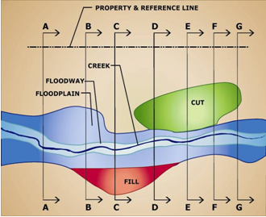
* Not to Scale & Topography not shown for clarity.

Figure 10-2 – Example Cross Section D-D
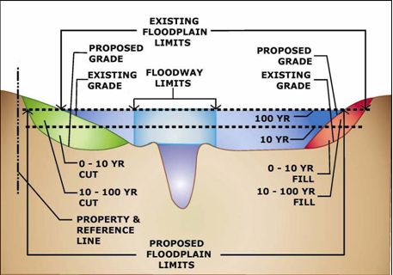

Table 1 - Example Compensatory Storage Calculations for 0-10 year event

Cross Section | Distance Between Sections (ft.) | Fill Area  (sq. ft.) | Average Fill Area (sq. ft.) | Volume of Fill (cu. Ft.) | Cut Area (sq. ft.) | Average Cut (sq. ft.) | Volume of Cut (cu. Ft.)
A |  | 0 |  |  | 0
 | 150 |  | 50 | 7,500 |  | 0
B |  | 100 |  |  | 0
 | 90 |  | 125 | 11,250 |  | 60 | 5,400
C |  | 150 |  |  | 120
 | 100 |  | 125 | 12,500 |  | 195 | 19,500
D |  | 100 |  |  | 270
 | 100 |  | 50 | 5,000 |  | 300 | 30,000
E |  | 0 |  |  | 330
 | 100 |  | 0 | 0 |  | 360 | 36,000
F |  | 0 |  |  | 390
 | 85 |  | 0 | 0 |  | 255 | 21,675
G |  | 0 |  |  | 120
Total Fill |  |  |  | 36,250 | Total Cut |  | 112,575

Since the total amount of cut provided (115,575 ft³ as shown in the table) is larger than that required (3 X 36,250 = 108,750 ft³), the design meets the compensatory storage requirement for the 10-year flood. An additional table and calculation should be completed for the 100-year flood elevation in a similar manner to determine whether the design meets the compensatory storage requirement for the 100-year flood.

Location of Compensatory Storage
Compensatory storage must be located on‐site and adjacent to or opposite the areas filled or occupied by a structure. In those rare instances when compensatory storage cannot be located adjacent to or opposite to the areas filled or occupied, engineering computations demonstrating that hydraulically equivalent compensatory storage at a minimum of 3 to 1 ratio has been provided is required. These computations must show that no increase in flood flows or flood depths will result as a result of the location of the proposed compensatory storage.

Compensatory storage must be constructed to drain freely and openly to watercourses. In some rare cases it may be necessary to install pipes to construct and/or operate a compensatory storage basin. This may occur when site constraints, such as a roadway or sidewalk, separate the waterway from the compensatory storage area. This is illustrated in the top half of Figure 10-3.

Another scenario may occur when a site cannot meet the incremental storage requirements discussed in this document. If incremental storage requirements from the 10‐year to 100‐year elevations cannot be met, pipes could be installed with a flap gate to prevent the water from entering from the stream bed at lower elevations. The berm could then be set at the elevation of the 10‐year flood elevation, thus allowing the storage to only become effective above the 10‐year flood elevation. This is illustrated in the bottom half of the illustration in Figure 10-3.

The use of pipes in compensatory storage will require approval by the County. If approved, two pipes will be required to reduce the risk of clogging. Pipes must be a minimum of 15 inches in diameter so as to allow water to enter and exit freely with a minimum head differential. If the compensatory storage is proposed to be combined with detention, it must be demonstrated the compensatory storage and detention do not interfere with one another.
Figure 10-3 – Example of Compensatory Storage Connection to Stream through Pipe
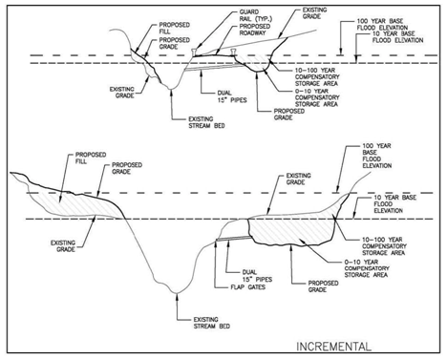

Compensatory Storage in the Regulatory Floodway
Only fill associated with appropriate uses of the regulatory floodway may be allowed to be placed within the limits of the floodway. When, in rare circumstances, fill is allowed, all provisions discussed above relating to compensatory storage must be met in addition to the items discussed below.

  - Any fill placed within the existing floodway must be compensated for within the proposed floodway.
  - All floodway storage lost below the existing 10‐year base flood elevation shall be replaced below the proposed 10‐year base flood elevation.
  - All floodway storage lost between the existing 10‐year flood elevation and the existing 100-year flood elevation shall be replaced between the proposed 10‐year and proposed 100-year flood elevation.

