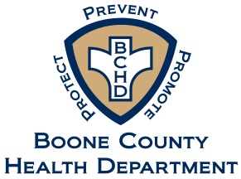
Environmental Division
Suite B201
(765) 483-4458
(765) 483-5243 Fax

_____________
Nursing & Vital Records Division
Suite B202
(765) 482-3942
(765) 483-4450 Fax

Boone County Health Department
116 W. Washington Street - Lebanon, IN 46052
www.boonecounty.in.gov/health

HEALTH BOARD AGENDA REQUEST FORM

Name of Requestor:
Address:
Phone Number: |  | Email Address:
Date of Request: |  | Date of Meeting:
Matter of Request:
Documents Attached:

Please email this completed form for considerations, along with all supporting documentation to Vickie Foster, Health Board Administrative Assistant at vfoster@co.boone.in.us, or hand deliver to the Boone County Health Department located at 116 W. Washington Street, B202, Lebanon, IN 46052

The Agenda Request Form submission deadline is at noon on the Friday prior to each Health Board Meeting, except when affected by a County Holiday or an Emergency Closing. For exact Health Board Meeting dates please refer to the Boone County Website Health Department.

